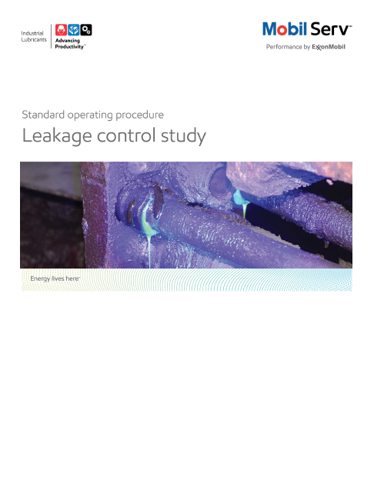

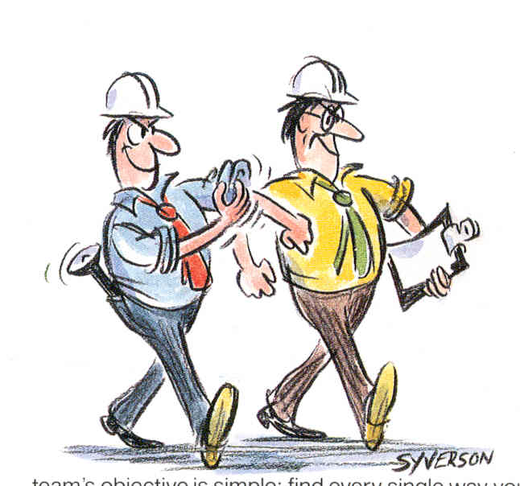
Standard Operating Procedure (SOP)
Read all of the steps in this SOP before beginning work. Follow customer labor requirements (eg respect Union work)

SOP: Leak Detection using fluorescent dye on Dynamic Equipment |  | DATE  4/30/2013 |  NEW  o REVISED  ___ Number |  | PAGE 1 of 12
TYPICAL CUSTOMERS  Industrial Plant (Paper, Steel, Gen. Mfg. Off-Hwy) | WORK TYPE  Leak Detection Study | WORK ACTIVITY (Description)  Identify source points of oil leaks on equipment including using Ultra Violet Dye.
DEVELOPMENT TEAM | POSITION / TITLE | REVIEWED BY/DATE |  | POSITION / TITLE
Brent Winter | Lubrication Engineer | Bill Fuller 7/29/2013 |  | FES Advisor/US West
Joe Cervassi | Lubrication Engineer | John Sewall 7/30/2013 |  | FES Advisor/US East
Toby Hlade | Lubrication Engineer | Tom Schiff 8/20/2013 |  | FEM Americas
PLEASE UTLIZE ATTACHED GENERAL JSA AS GUIDANCE AND, IF YOU HAVE DONE A SITE SPECIFIC JSA.
PLEASE ASSESS YOUR OWN CONDITIONS OR SPECIFIC SAFETY REQUIRMENTS AND BE SAFE. http://intratta.na.xom.com/emdn/sbps/docs/safety/jsa/JSA_Leak_Detection.xls
EQUIPMENT INDEPENDENT OF JSA DESIRED DOCUMENTATION
 CLIPBOARD   UV INSPECTION LIGHT (ie OPTIMAX 3000 or OPTIMAX JR) AND ENHANCING GLASSES   HIGH POWERED FLASHLIGHT   FLUORESCENT DYE (ie SANDY BRAE LIQUID YELLOW F6HF)   SEALABLE PLASTIC BAG FOR REMAINDER of DYE   DISPOSABLE OUNCE CALIBRATED MEASURING CUP AND/OR  GRADUATED CYLINDER WITH FUNNEL   NEOPRENE GLOVES, RAGS   CAMERA  CHECK WITH CUSTOMER : OK TO USE OWN TOOLS OR MUST BE CUSTOMERS |  |  DAY OF - ENGINEERING SERVICE NOTICE (ESN) AS LEAVE  BEHIND   FINAL - ESR WITH TCO SAVINGS
TIME ESTIMATED TO COMPLETE THIS TASK NUMBER OF PEOPLE TO PERFORM THIS TASK
~0.5-1 HOUR PER SYSTEM DEPENDING ON COMPLEXITY |  | 1 -2
FREQUENCY TO PERFORM THIS TASK SKLLS REQUIREED TO PERFORM THIS TASK
DEPENDS ON NEED AND CUSTOMER COMMITMENT, USUALLY 1 -2 TIMES PER YEAR MAX. NOTE: DYE WILL REMAIN ACTIVE UNTIL DILUTED THROUGH MAKEUP. |  |  MECHANICAL APPTITUDE   DISCUSS OPERATING CONDITIONS WITH OPERATORS /  MECHANICS   OBSERVE AND COUNT OIL LEAKAGE; DROPS PER SECONDS
JOB COMPETANCIES REQUIRED TO PERFORM THIS TASK, |  | TRAINING REQUIRED TO PERFORM THIS TASK
 PRODUCT SELECTION   OFFER EXECUTION - BASIC OFFER EXECUTION, HYDRAULIC  SYSTEM INSPECTIONS   INDUSTRIES - GENERAL MANUFACTURING  APPLICATIONS - Hydraulics, Circulating systems |  |  INSIDE SALES- (TECHNICAL RESOURCES - MODEL  DOCUMENTATION- ENGINEERING SERVICE REPORTS-  LEAKAGE STUDIES)   FMC TEAM SITE – TELECONFERENCES – FES PERFORMING LEAKAGE CONTROL STUDY AND DOCUMENTATION IND THUNDER CALL AUG 2012  http://ishareteam4.na.xom.com/sites/LSLAM001/Field_Marketing/US/Industrial%20Thunder%20Calls%20New/FES%20Performing%20Leakage%20Control%20Study%20and%20Documentation%20IND%20Thunder%20Call%208%2013%2013%20rev01JS[1].ppt   ON THE JOB TRAINING   SITE SPECIFIC CUSTOMER ORIENTATION

Purpose - To describe the process of implementing a Leakage Control Program based on customer needs, establishing baselines, conducting studies to reservoirs and components, with the desired reporting that provides the value back to the customer while supporting the standard Marketing Offer.

(External Offer Sheet: http://intratta.na.xom.com/emdn/sbps/technical/engg_services/Americas/Comprehensive_Leak_Detection.pdf)

(Internal Offer Sheet: Place holder when available)

Activity | JOB STEPS
Feasibility Prerequisite and Gathering Baseline Data | Ensure What a Leakage Control Study produces is understood for the Customer  - An oil leakage control study is the detailed examination of a customer’s complex lubrication or hydraulic system for oil loss which could be avoided.  Ensure Why doing a Leakage Control Study is beneficial for the Customer  - Confirm and quantify the customer realizes value in these areas:  - Reduced Maintenance Costs (Oil Expenditures and Assets)  - Reduced Environmental Impact (Fines for oil leakage/spills)  - Reduced Coolant Contamination (Improved Revenues)  - Reduce Slip Hazards (Process and Safety Improvements)  - Maximizes Equipment Availability (Improved Revenues)  - It is a valuable tool in assisting customers identifying sources of excessive oil consumption.  - Allows us to identify sources of contamination and mechanical issues that impact oil and equipment life.  - Fosters a supplier-customer bond which is valuable in preserving future business.  - Endorses many customer corporate mission statements of reduce, reuse, and recycle regarding safety, sustainability, and evergreen.  When to conduct a Leakage Control Study  - When customer agrees oil consumption is excessive. Show the Lubricant Fluid Index calculation and when great than 2 is a good opportunity to conduct a leakage control study:  LFI = Consumption (gals or ltrs) / Reservoir Capacity (gals or ltrs)  English Units Example; 2 = 2,000 gals consumed / 1,000 gal capacity  (Metric Example: 2 = 10,000 liters consumed / 5,000 liter capacity)  - When customer has resources to act on your recommendations to correct identified leaks and equipment deficiencies.  Understand Customer oil consumption and measurement methods  - Obtain a reliable estimate of current consumption rates for each system. Metered measurements are preferred versus oiler or operator feedback. For best overall program success, an ongoing system for consumption tracking by reservoir is highly recommended. The following strategies have been successful.  - Where a small number of oilers are responsible for additions, install fill meters on the fill equipment and have the oilers log individual additions. Use a spreadsheet or database to trend this information regularly.  - Where many individuals may add oil, install permanent, totalizing fill meters at each reservoir to record fills. Record the totalizer reading on a regular basis and trend values to determine usage rates. A linear fit of the totalizer reading versus the date of the reading will give a slope equal to the average gallons/day.  - For large systems, always read meters at the same fill level or measure fill level with the readings to account for variations. A measuring tape can be applied at the sight glass to give a stable reference. Calculate the gallons/inch of height for the reservoir and use this with the level to determine current quantity. Add this to the fill meter reading to arrive at an adjusted meter reading.  Good consumption tracking answers 3 critical questions necessary for effective oil leak inspections. Ultraviolet (UV) Dye when used in leakage control studies can show the customer exact points of leakage and allows the field engineer to better estimate leakage quantities. The other benefits using UV dye are from :  Where to Look – By identifying the high consumers  When to Look – By identifying when new, significant leaks develop  When to Stop Looking – By comparing the sum of leaks identified to the known consumption rate  - Gather consumption tracking information from the plant and identify high users for inspection. For larger systems, look at increases in trends to show when new leaks have developed.  - Identify system capacities for determining the amount of dye needed.
Planning the Study | - Schedule the event.  - Obtain customer work permit, safety orientation, and the understanding of the scope of the project  - Submit MSDS and obtain customer approval for use of the UV dye in their systems.  - Obtain the necessary amount of UV dye for the systems to be inspected. For large amounts, the dye should be purchased by the customer.  - Arrange for plant personnel to assist. It may be necessary to remove guards or cycle parts of the system to fully evaluate all components.  - Allow for at least one hour per machine. If possible, machine should be out of production, but available to cycle. The machine should be empty of any production parts.  - Review the machines ahead of time with plant personnel to determine safety concerns or requirements and to plan the inspection process. For larger systems, this may be most effective during an outage when more areas are accessible.  - If possible, get lubricant system schematics or piping diagrams. This can help to identify hidden components and key target areas for inspection.  - Discuss with plant personnel options for tagging leaks on the machine. Tags can be an effective tool for relocating leaks and tracking repairs, but are not necessary with good photographic documentation.
Conducting the Study | - Before leaving customer office, refer to all applicable JSAs.  - Add dye to the reservoir 1-24 hours prior to the inspection. Typical rates are (English Units = 7 ounces / 100 gallons of reservoir capacity) (Metric Units = 207 ml / 379 liters of reservoir capacity). Longer time periods are required for larger systems. Add the dye through the fill cap or other suitable opening at the specified treat rate. Cap remaining dye tightly and secure in a sealable bag. Store only in well ventilated area such as garage or shed.  - The machine should be run normally while the dye circulates, to allow leaks to bloom. It is not sufficient to merely have the lubricant pumps on. All points need to be actuated/cycled repeatedly, as they would with normal operation to see leaks when the lubricant is under pressure.  - After sufficient time has passed, begin searching for leakage using the UV light. Begin searching in areas where leakage oil would drain or collect in order to find large accumulations. Trace those points back to the source.  - Ensure you look at all components where leakage may occur and contamination source points; supply/return lines and fittings, oil coolers, pumps, actuators, valves, oil flow meters, control panels, multiple operating levels for machines.  - For machine tools with metalworking fluids, inspection is most effective if the machine can be cycled without coolant flow. Coolant washing away leaks is why many go undetected. Check the surface of the coolant for signs of dyed oil popping to the surface to verify leakage into the coolant.  - Measure or estimate each significant leak and record the rate. For moderate leaks, count drops over several seconds with a timer to get an average rate. For larger leaks, use a timer and graduated cylinder to get an accurate rate.  Note: Leaks less than 1 drop/second are generally not a concern.  - Work with plant personnel to estimate repair costs associated with each leak to determine accurate TCO. Include labor, downtime and part costs.  - For significant leaks that present a significant repair challenge, consider options for leakage collection and reclamation.  - Some leaks may only occur when the lubricant system actuates a certain way. Have plant personnel actuate cylinders individually to observe in both positions. Take extra precautions to ensure safety when the machine is in motion. For intermittent leaks, multiply the maximum rate by the estimated percentage of time in that position.  - Photograph all significant leaks and document their rates. Compare rate totals to the overall consumption to determine success and when the inspection is complete.  - While some leaks may be repaired quickly during the inspection, focus plant personnel on identification and documentation. This will ensure that you return the machine to production as quickly as possible. Repairs should then be planned to have minimal impact with production.  Photography Tips  - Take pictures with and without the flash. The flash tends to wash out the effect of the dye, but is needed to get remaining detail.  - If possible, set the camera to a High ISO level. This increases sensitivity and detail when not using the flash. However, higher ISO will increase graininess of the photos.  - Use a large arrow to pinpoint leaks in the photos. This saves time over annotating photos later.  - Take close-up and wide angle shots to ensure the location can be identified later.  - If possible, use a yellow filter on the camera to highlight the dye in the same way that the yellow safety glasses do.
Follow-Up | - UV dyes are stable and may be left in the system. They have not shown tendency to cause deposits, affect servos or be detected through oil analysis. They will eventually dilute over time with normal make-up.  - Document all significant leaks in a detailed Engineering Service Report for the customer.  - Follow up with the customer regularly to track the progress and success of repairs.  - Continue to monitor oil consumption on all systems to prove savings and identify onset of new leakage.
Feedback about this SOP - send to Field Engineering Advisor/Supervisor | .

DOCUMENTING YOUR WORK –

The Leak Detection Study is used to minimize oil loss and re-lubrication maintenance resulting from complex and simple lubricant system leaks. The deliverable format is the 3D Writer Engineering Service Report. TCO calculations that may apply are: Revenues, Process, Expenditures and Assets. Make sure to include the negative TCO costs defined as what the customer will need to invest in the total recommendations from this study. Dye cost is one example along with devices and systems to capture oil leaks, reclaim in house and other related equipment.

Revenues – Increased production can result from ensuring maximum equipment availability and reduced Coolant contamination in cases of metal working applications. The latter case, coolant reservoirs, can be overloaded if too much hydraulic or circulating oil leaks into the coolants reclamation process causing production interruptions to dump and retreat coolants.

Processes – reduced leaks can decrease lubrication maintenance staffs’ time to work on leaks. Discuss with your customer all the time factors their maintenance staff encounters to add oil lubricant to systems with leaks. Include all aspects of; identifying the equipment, determining the correct lubricant, drawing the lubricant from inventory, filling at the equipment, returning dispensing equipment, additional filtration that might be used, and ordering replenishment product for inventory. This also represents a Safety benefit by reducing the potential for slips from oil leaks on walkways. This factor requires sensitivity when trying to determine a value to document but review this with the customer to see how applicable they will allow documentation.

Expenditures - reduced lubricant purchase costs are the most typical expenditure savings. An additional expenditure may come from disposal costs of used lube and oil filter replacements. Find out how much the unit cost of disposal is and use the consumption on an annual basis. Review oil filtration costs, oil dri and oil leak absorbent materials for their costs. Include the costs to implement your recommendations as “negative TCO”; e.g. UV Dye costs, Tray catch pans, oil bulk containers, recycling equipment, additional oil testing, pipe and fitting replacements, TLM Oil Leakage (ILS) jobs to remove old deposits that can be the root cause for oil backing up and leaking in return lines. This would be a onetime cost that has a long term benefit in future years.

Assets – The Possession Cost of money is captured with Assets. We estimate this Possession cost is 20% of the Expenditure for replacement items, e.g. oil replenishment year after year. Therefore, if $10,000 is the annual consumption that is corrected by implementing the Leakage Study recommendations, multiply $10,000 by 20% = $2,000 for the Asset TCO value.

Summarize your findings. This example described three categories and negative TCO. Please use caution to state the waived fee of Mobil engineering services. This example has tis in the category but the study itself has sufficient value described from the study to not include this element.

Asset Improvement
TCO Components Impacted | (A)  Quantities Reduced |  | (B)  Value  of Asset |  | (C) Possession Cost (%) |  | Dollars  Freed  (A∗B) |  | Asset Savings = (A∗B)∗C
English Units
Reduced lubricant consumption |  | 1,360 gals |  | $9.00/gal * |  | 20% |  | $12,240 |  | $2,448
Metric Units
Reduced lubricant consumption |  | 5,148 ltrs |  | $2.378/ltr * |  | 20% |  | $12,240 |  | $2,448
Note: Possession Costs = Interest, taxes, insurance, shrinkage/spoilage,  maintenance storage and other possession costs as an annual percentage of  the purchase price of the asset. |  |  |  |  |  |  |  | $12,240 |  | 2,448
 |  |  |  |  |  |  |  | Total Dollars Freed |  | Total Possession Cost Savings
Notes:
Mobil engineers documented hydraulic oil leaks that total at least 1,360 gallons (5,148 ltrs) per year. Assuming a cost of about $9.00/gal ($2.378/ltr), and a possession cost of 20%, this is a cost savings of at least $2,448.

Process Improvement
TCO Components Impacted |  | (A)  Past Process Costs |  | (B)  Frequency of  Past Use |  | (C)  Current Process Costs | (D)  Frequency of Current  Use | Process Savings =  (A∗B) –  (C∗D)
Lubricant top-off costs (14 hours) |  | $40/hour |  | 14 hours |  | $40/hour | 0 hours | $560
Floor clean-up cost savings (5 hours) |  | $40/hour |  | 5 hours |  | $40/hour | 0 hours | $200
 |  |  |  |  | Total Process Savings |  |  | 760

Notes:
It can be assumed that adding 100 gallons (378 ltrs) of oil to this reservoir could require as much as an hour to complete. At 1,360 gallons (5,148 ltrs) per year, this equates to about 14 oil top off sessions. It is assumed that cleaning up leakage oil would require 5 hours per year.

Expenditure Reduction
TCO Components  Impacted |  | (A)  Annual Quantities Impacted |  | (B)  Price  Differences |  | Annual  Savings  A∗B
English Units
Reduced Lubricant Purchasing |  | 1,360 gal |  | $9.00/gal |  | $12,240
Reduced Lubricant Disposal |  | 1,360 gal |  | $0.50/gal |  | $680
Metric Units
Reduced Lubricant Purchasing |  | 5,148 ltr |  | $2.378/ltr |  | $12,240
Reduced Lubricant Disposal |  | 5,148 ltr l |  | $0.132/ltr |  | $680
 |  |  | Total Expenditure Reduction |  | $12,920

Notes:
Making the repairs to the identified leaks will reduce oil consumption by 1,360 gal (5,148 ltr) / year and reduce oil disposal costs.

Resources

UV Lights
- Spectronics Corporation produces a wide range of UV lights under the Tracerline Brand. The Optimax 3000 model provides a good balance of power, portability and price. It can be found at many online retailers for $100-150. www.tracerline.com

Dyes
- Sandy Brae offers two colors of UV dye in various package sizes. www.sandybrae.com
- DSI Inc also offers similar dye (703) 250-0976.
- Tracerline also offers dye, but styles and packaging are not well matched for industrial lubes. They do offer a wider range of products for different fluid types.

Collateral & References
- Mobil Technical Topic – Leakage Control (HFI)
http://www.mobil.com/IND/English/Files/tt-leakage-control.pdf
- Hydraulics & Pneumatics Magazine, Nov 2005, “Take Control of Leakage”, Toby Hlade
- Service Data Sheet – Leakage Oil Reclamation (Harte-Hanks SDS0005)
- Expert Lubrication Services – Comprehensive Leak Detection (Harte-Hanks ELS003SH)
- ExxonMobil Oil Lost From Leakage Magnet (Harte-Hanks ENCRD0501)
- Oil Lost From Leakage & Viscosity Equivalents Pocket Card (Hart-Hanks GEN087002)
- Inside Sales – Several report examples available for leakage studies
http://intratta.na.xom.com/emdn/sbps/technical/model_doc/model_doc_esr_ser_leakage_studies.html

Oil Lost from Leakage
Leakage Rate | Lost Oil (Gallons)
Leakage Rate | Per Day | Per Month | Per Year
1 Drop/10 Seconds | 0.112 | 3.36 | 40
1 Drop/5 Seconds | 0.225 | 6.75 | 81
1 Drop/Second | 1.125 | 33.75 | 405
3 Drops/Second | 3.75 | 112.5 | 1,350
Drops Break Into Stream | 24 | 720 | 8,640
1/16” Stream | 92 | 2,750 | 33,000
1/8” Stream | 285 | 8,550 | 102,600
3/16” Stream | 467 | 14,000 | 168,000
1/4” Stream | 1017 | 30,500 | 366,000

Photographic Examples

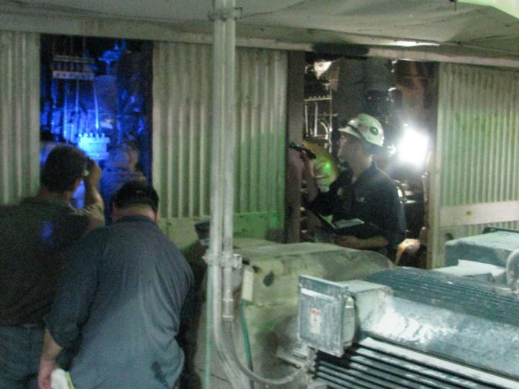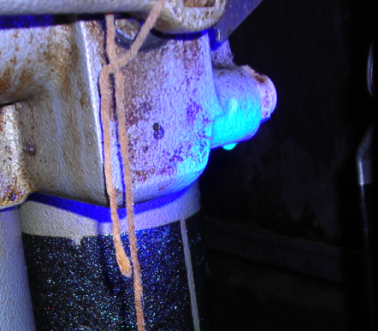
Photograph with UV Light and normal setting to demonstrate how the dye and UV light show exact position of leaks.

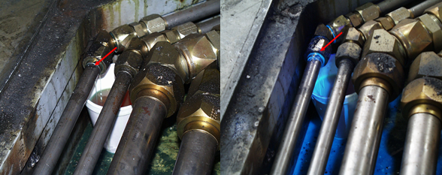
Use flash for normal lighting (left photo) and turn off flash to show the impact of the UV dye (right photo)

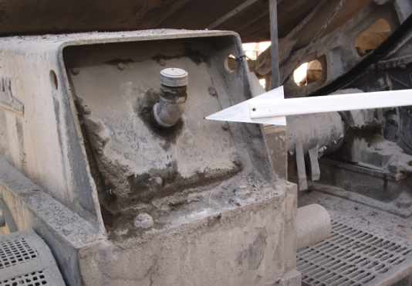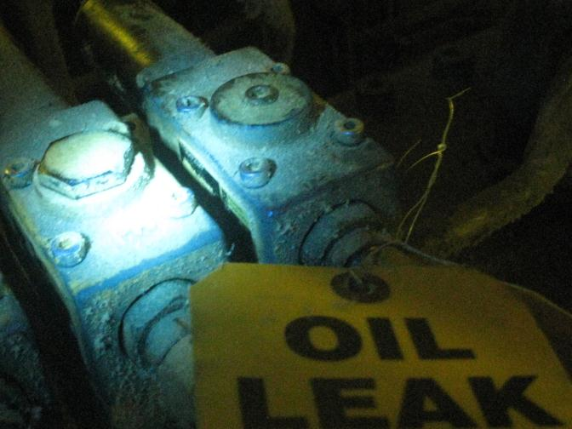
Use a pointer in normal light to indicate area of leakage and to aid repairs crew when writing the ESR, or attach lube leak ID tag at the leak point.
- Publish photographs and details of finding with ESR.

Example ESR: http://mysite.na.xom.com/personal/na_wtfuller/Shared%20Documents/SOP's/FutureMark_Paper_Oil_Leak_Detection_07_2012_bowser.docx

