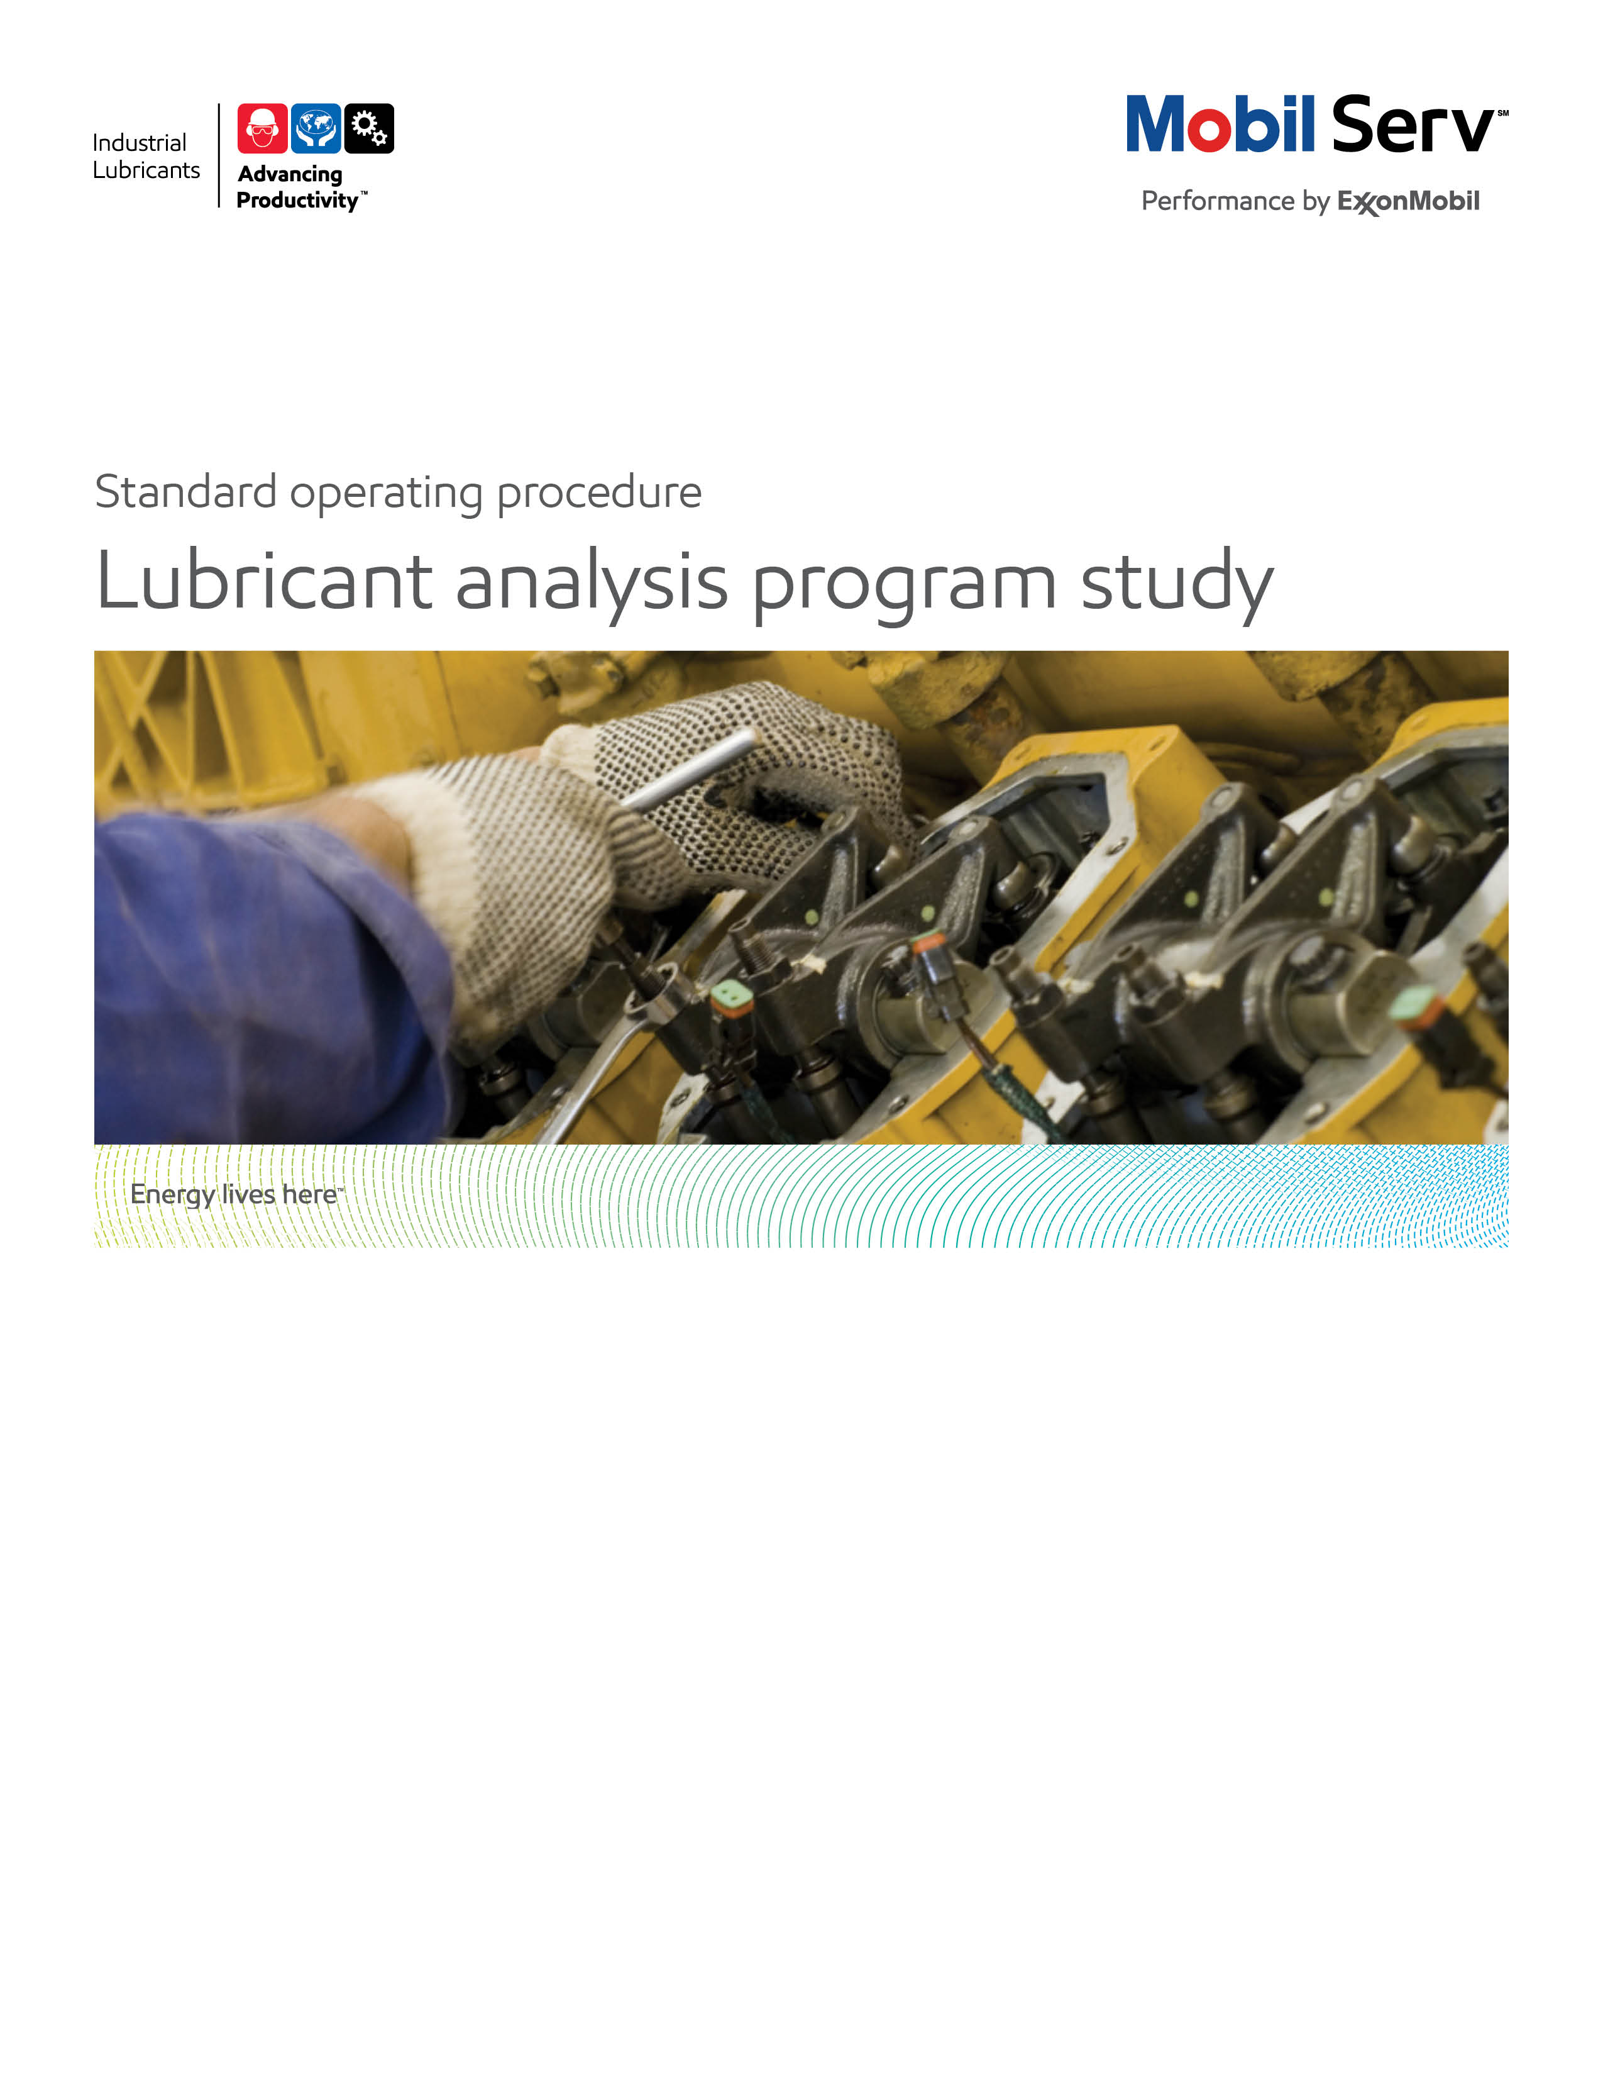



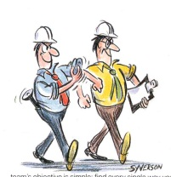

**Standard Operating Procedure** **(SOP)**

**Read all of the steps in this SOP before beginning work.** **Follow customer labor requirements (eg respect Union work)**

|  |  |  |  |  |  |
| --- | --- | --- | --- | --- | --- |
| **SOP: Lubricant Analysis Program Study (includes Mobil Serv Lubricant Analysis Summary Reports)** | | DATE  9/17/15 | | ⌧ NEW  REVISED  ___ Number | PAGE 1 of 14 |
| TYPICAL CUSTOMERS  Off Highway, Paper, Primary Metals, General Manufacturing, O&G, Energy | WORK TYPE  Lubricant Analysis Program Study | WORK ACTIVITY (Description)  Conducting in-depth study of select customer’s in service lubricant analysis program to make continuous improvement recommendations as well as recognize achievements from their program | |
| **DEVELOPMENT TEAM** | **POSITION / TITLE** | **REVIEWED BY/DATE** | **POSITION / TITLE** |
| Gilles Delafargue | Global FES Advisor | Tom Schiff | Global FES Manager |
|  |  |  |  |
| **PLEASE UTLIZE ATTCHED GENERAL JSA AS GUIDANCE AND, IF YOU HAVE DONE A SITE SPECIFIC JSA.**  [**http://intratta.na.xom.com/emdn/sbps/docs/safety/jsa/JSA_Mobile_Equipment_Inspection.xls**](http://intratta.na.xom.com/emdn/sbps/docs/safety/jsa/JSA_Mobile_Equipment_Inspection.xls)  [**http://intratta.na.xom.com/emdn/sbps/docs/safety/jsa/2012/Off_Highway_Construction_Account_Visit.xlsx**](http://intratta.na.xom.com/emdn/sbps/docs/safety/jsa/2012/Off_Highway_Construction_Account_Visit.xlsx)  [**http://intratta.na.xom.com/emdn/sbps/docs/safety/jsa/Mine_Site_Visit_JSA.xls**](http://intratta.na.xom.com/emdn/sbps/docs/safety/jsa/Mine_Site_Visit_JSA.xls)  [**http://fllubes.na.xom.com/docs/safety/jsa/JSA_Lube_Survey_General_Plant.xls**](http://fllubes.na.xom.com/docs/safety/jsa/JSA_Lube_Survey_General_Plant.xls)  **PLEASE ASSESS YOUR OWN CONDITIONS OR SPECIFIC SAFETY REQUIRMENTS AND BE SAFE.** | | | |
| **EQUIPMENT INDEPENDENT OF JSA DESIRED DOCUMENTATION** | | | |
| ⌧ COMPUTER  ⌧ MASK  ⌧ FLASHLIGHT  ⌧ SAMPLE THIEF, BOTTLES & LABELS  ⌧ SAMPLE POINT LABELS; EXAMPLE SAMPLE PORTS  ⌧ MOBIL FIELD TEST KIT (Water, TBN/TAN, Glycol, Filter Patch)  ⌧ LINT FREE RAGS  ⌧ STILL CAMERA  ⌧ VIDEO CAMERA  CHECK WITH CUSTOMER : OK TO USE OWN TOOLS OR MUST BE CUSTOMERS | | ⌧ SAMPLING PROCEDURES  ⌧ DATA HARVESTER DATA (TYPICALLY PART OF ESR)  ⌧ MEETING DOCUMENTATION.  ⌧ FINAL - ENGINEERING BENEFIT REPORT (ESR) WITH TOTAL COST of OWNERSHIP (TCO) SAVINGS  **OTHER (SPECIFY**)  ⌧ PRESENTATION WITH RESULTS AND TCO | |
| **TIME ESTIMATED TO COMPLETE THIS TASK** **NUMBER OF PEOPLE TO PERFORM THIS TASK** | | | |
| FOUR HALF DAYS FOR UOA DATA SUMMARIES AND ANALYSIS  ONE HALF TO FOUR DAYS COLLECTING OPERATIONAL DATA, EQUIPMENT REPAIR DATA, AND CONDUCTING INFIELD EQUIPMENT INSPECTIONS, OBSERVING SAMPLING PROCUEDURES, ETC.  ONE FULL DAY TO PRODUCE THE FINAL ESR | | TYPICALLY 1 FIELD ENGINEER BUT MAY REQUIRE SALES ADVISOR, DSR, AND/OR DLE SUPPORT. CONSIDER CUSTOMER PERSONNEL SUPPORT (RANGE FROM HOURS TO DAYS MAINLY FOR DATA GATHERING) | |
| **FREQUENCY TO PERFORM THIS TASK** **SKLLS REQUIREED TO PERFORM THIS TASK** | | | |
| DEPENDS ON CUSTOMER COMMITMENTS, USUALLY 1 TIME PER 2 OR 3 YEAR FOR PROCESS SECTION – ALSO DEPENDING ON CHANGES TO FLEET EQUPMENT MIX AND OR DUTY CYCLE | | ⌧ MECHANICAL APPTITUDE,  ⌧ PRODUCT KNOWLEDGE  ⌧ EQUIPMENT AND LUBRICATION APPLICATION, lms  ⌧ MOBIL SERV LUBRICANT ANALYSIS (MSLA) SKILLS  ⌧ ADVANCED LA INTERPREATION SKILLS – DATA HARVESTER  ⌧ FIELD CONDITIONS INTERPRETATIONS  ⌧ FAILURE ANALYSIS | |
| **JOB COMPETANCIES REQUIRED TO PERFORM THIS TASK,** | | **TRAINING REQUIRED TO PERFORM THIS TASK** | |
| PRODUCT SELECTION.  EQUIPMENT INSPECTIONS  LUBRICANT ANALYSIS  BENEFIT SELLING  PERSUASSIVE COMMUNICATION | | ⌧ PRODUCT KNOWLEDGE AND RECOMMENDATIONS  ⌧ EQUIPMENT APPLICATION  ⌧ TROUBLE SHOOTING PROBLEMS/FAILURE ANALYSIS  ⌧ EQUIPMENT INSPECTIONS (INFIELD, MID LIFE, OVERHAUL).  ⌧ UOA INTERPRETATION. (BASIC AND DATA HARVESTER)  ⌧ HOW TO USE LTS  ⌧ SITE SPECIFIC SAFETY TRAINING | |
| **OTHER RESOURCES REQUIRED OR SUPPORT** | |  | |
| ⌧ TECHNICAL HELP DESK ([tsc.amerias@exxonmobil.com](mailto:tsc.amerias@exxonmobil.com))  ⌧ www.mobilindustrial.com  ⌧ www.looble.com  ⌧ GLOBAL FES SHAREPOINT – TECHNICAL LIBRARY | | ⌧ LTS (LUBRICANT TECHNICAL SUPPORT)  ⌧ DATA HARVESTER  ⌧ MSLA PRGRAM OR CUSTOMER’S LA PROGRAM | |

**PURPOSE -** To describe the steps to conduct an in-depth study of select (typically PES) customer’s in service oil analysis program. The study aims to document the successes of their program (with evidence of our active support) as well as identify continuous improvement opportunities. The goal of these studies is provide customers value by optimizing their equipment reliability, uptime, maximize their lubricant program and reduce waste.

External Offer Sheet: Placeholder

Internal Offer Sheet: Placeholder

**INTRODUCTION**

This guide is based on experiences of using Mobil premium and flagship products, robust understanding of UOA, and leveraging our Mobil Serv Lubricant Analysis/Data Harvester programs and tools. Note that appropriate storage and handling procedures, quality of equipment registration and sample labelling, as well as use of relevant sampling procedures are key elements impacting optimization of the use of MOBIL SERV Lube Oil Analysis program.

The commitment required by ExxonMobil and the customer's staff should not be underestimated. It is therefore imperative that proper planning and identification of the expected outcome, risks and impact on the Total Cost of Ownership, for both ExxonMobil and the customer, is completed before starting suggesting/implementing recommendations. To maximize the study results, ExxonMobil persons should have an excellent cooperative relationship with the customer.

These are suggested guidelines that can be adapted as needed in conjunction with your local Field Engineering Support team.

|  |  |
| --- | --- |
| **LOCATION** | **JOB STEPS** |
| 1-Early stages at customer site and home office | Collect baseline data to prepare for initial customer discussions:   * Conduct a feasibility analysis using existing used oil analysis data to assess the health of the customer’s lubricant analysis program (especially verify if there is enough historical data to be able to draw conclusions). * Understand applications/ how the equipment are operated * Collect the predominant equipment make/models being used. * Identify suffering points through discussion with customer * Conduct initial MSLA/data harvester analysis (in some cases you will need to gain access to customer lubricant analysis (LA) data from 3rd party lubricant programs/outputs to look for opportunities to discuss with customer * Review data from previous customer visits – especially repair data based on LA alerts as well as equipment reliability issue data (failure, repair incidents, rates) * Outline what you currently understand about the customer’s LA program |
| 2-Customer Site (combination of maintenance offices and equipment operations) | Confirm customer alignment/commitment to conduct a cooperative study.  Then based on initial findings, handle more in-depth site visit(s) to collect information missing. Obtain first agreement from customer to take photos to further document your report and proposals   * Establish the list of all equipment on site that would require follow up by analysis * Establish the list of equipment really followed by analysis * Collect detailed information of all equipment currently followed up by analysis (in view confirm proper registration in system) * Collect detailed information of all equipment currently not followed up by analysis (for further proper registration in system) * Identify key equipment reliability improvement areas. These could include the following:   + Equipment/components with higher than desired (or above industry average for the application) repair/failure rates. This may require interviewing multiple customer contacts, researching their computer maintenance management system equipment history, store room records, interviewing/talking to other equipment suppliers/EBs to the customer, lubricant consumption   + Action taken using LA data both successes as well as false positives (where LA results indicated an issue but none were found) or missed positives (where LA results failed to identify an issue or where the customer had LA data that indicated an issue but they failed to act as best as possible) with the aim to further maximize the LA usage   + Survey the customer’s operation to ensure you have a good understanding of the operational/maintenance challenges. Avoid just conducting a table top exercise * Identify the current storage and handling procedures at customer site * Identify the current sampling and labelling procedures at customer site * Using the information gathered to build the baseline and considering the identified needs of the customer, establish the value of the benefits for the customer. * As a best practice, you should generate an initial findings service notice to leave with the customer to highlight the identified opportunity areas |
| 3-Home office and Customer Site | Based on the initial data gathered, analyze the customer’s LA data and practices including leveraging data harvester (for MSLA – formerly Signum customers). Some of the items to review (on the equipment identified as material to the study – could/should include general observations) include:   * Review LA equipment registrations to ensure the customer has the right equipment registered under the right test slates * Advise customer to correct inappropriate or incomplete registrations * Evaluate if the customer fills in the optimum information on sample labels so as to best analyze the oil (oil hours, equipment hours, operating temperatures, data sampled, other comments, etc.) * Review data harvester (for MSLA/Signum customers) to identify trends, compare to similar customer/application/product populations * Identify Sample frequency by application * Verify if Sample point locations are correct * Identify Who obtains samples * Identify and describe sampling procedures (e.g. how do they flush sample ports, lines, etc.)? * What condition is the equipment operating when they obtain samples (stopped, running , …) * Review documentation/work instructions given to persons obtaining the samples – best practices include instructions with equipment photos * Evaluate the time it takes from customer obtaining the sample from the equipment, to shipping to the lab, to lab receipt, to sample data generation/reporting back to the customer * Understand once the customer receives the LA reports/alerts how do they manage alerts? How do they trend non-alerted data? Do they use both absolute and trend alarming? How does the customer convert data into action? * Evaluate influencing factors to abnormal results such as lubricant storage and handling practices, oil sampling practices, equipment rebuild practices, equipment operating conditions (do they operate within design, contamination control practices/controlling ingression/removing ingression, etc…) * How does the customer correlate other predictive maintenance techniques with LA data (e.g. standard vibration data, acoustic ultrasonic vibration data, thermography, etc.)? * How does the customer validate the equipment repaired due to LA data? Did the equipment exhibit the expected abnormal conditions? * How does the customer follow up with LA after corrective action taken to ensure the LA returns to expected results? * How does the customer specifically use LA data to make proactive maintenance actions (balancing, alignment, purification, contamination control, etc.)? * Evaluate the customer’s LA data to evaluate if the LA alert/alarm limits are optimized. * How does the customer promote LA program successes to build confidence in the program with key customer stakeholders? * Based on the above analysis, evaluate if their lubricant/lubrication/maintenance practice recommendations, can improve their equipment/lubricant reliability? * Based on the above analysis, evaluate if the LTS lab can play a role to uncover root causes of abnormal equipment/lubricant condition that the LA has not identified (filter analysis, deposit analysis, analytical ferrography, SEM analysis, etc.)? If so, initiate a project with LTS. * Utilize the Mobil field test kit to correlate LA results or identify other opportunities. The most likely test that will yield insights will be the filter patch test. * On a regular basis review important LA results (best practice is to have customer alerts sent to Sales Advisor/Field Engineer/Distributor Sales Representative/Distributor Lubrication Engineer – have clear understanding of who will do this work) with the customer and provide periodic summaries (with review of alerts, as well as non-alerts, looking for trends, etc. during the year (best practice quarterly quick summaries – Look for recommendations/assistance to help the customer leverage the LA alerts. These are sub activities to support the overall project/objective; not individual objectives themselves)   Based on analyzing the above information and in cooperation with the customer (try to make it their idea with your help – create ownership), make improvement recommendations to improve their program with a direct tie to their current or potential suffering points  In addition to the above analysis, document customer successes with LA especially where we had involvement in the analysis and corrective recommendations creation. It is OK to document the actions just taken by the customer using LA but the real illustration of how we add value is when we document our active involvement in their use of the LA – **KEY COMPETITIVE DIFFERENTIATOR**  Using the above work create an Engineering Service Report (ESR) or Engineering Benefit Report (EBR) using Mobil Serv 3D Power Writer. Typically the ESR makes recommendations with potential savings and the EBR documents the benefits obtained from previous recommendations. In some cases, a report can have both potential/proposed recommendations/value with actual/realized value. In many cases, customers accept both as actual value. |
| 4-Customer site | Handle regular visit to customer to monitor the post analysis after corrective action has been taken |

**DOCUMENTING YOUR WORK** - The Lubricant Analysis Program Study procedure is used enhance the productivity of the customers by increasing the availability of the equipment and reducing the expenses related with lubrication/maintenance. This activity requires developing an initial Engineering Benefit Proposal (EBP) and after study should produce an Engineering Benefit Report (ERP). This two phase documentation will highlight value to the customer in terms of Productivity, Safety and Sustainability to support the general Marketing Offer.

**TCO calculations that apply**

TCO calculations that may apply are Expenditures Reduction, Process Improvement, and Revenue

Enhancement and Asset Improvement as detailed below. The TCO Worksheets are the preferred format to include in your report. .

Expenditure Reduction - reduced lubricant and equipment maintenance purchase costs are typical expenditure savings. These result from the offset of extending oil drain intervals, reduced equipment repairs, etc. from the previous lube against the increased price of the investments to achieve the savings. Other expenditure reduction comes from disposal costs of used oil or failed equipment disposal. It is important to account for the costs of our recommendations in addition to the benefits of the recommendation to achieve the TCO.

Process Improvement - the hourly wages (including burden) for personnel to perform existing tasks. As lubricant change outs are reduced, use these to determine process improvements. As lubricant usage is reduced, use the time to handle drums and the time to dispose of used lube to determine process improvements.

Revenue Enhancement - any serious abnormal equipment system or lubricant condition observed may be repaired during normal maintenance and reduce the potential for downtime. “Unscheduled Downtime”, resulting in lost production and most often, scrapped parts or material.

Asset Improvement - use the customers "cost to carry" (usually 20%) inventories. This is used from the Expenditures components for example, as you reduce the quantity of lube needed, take that amount cost and multiply by the "cost to carry" to determine the Asset value.

Safety Improvement – this is typically man-hours of avoided equipment interface exposure by increasing time between lubricant application/changes, reduced equipment repairs, etc. This could also include incidents caused by slips but do not document improvements in actual number of accidents or incident rates but rather the potential to impact those statistics.

Environmental Improvement – this is typically quantified by reduced lubricant volume disposed or reduced CO2 emissions

Refer to Expenditure Reduction, Process Improvement, Revenue Enhancement, and Asset Improvement to develop TCO. The Total Cost of Ownership (TCO) Database has many equipment typical costs in it, or consults with the OEM or equipment distributor to finalize your TCO. In all cases, ensure your customer agrees with the cost estimates. Sometimes you may need to suggest an estimated cost and get the customer to agree/negotiate to acceptable figures.

[TCO Database](http://intratta.na.xom.com/emdn/sbps/technical/TCO_Databases.html)

Include any “negative” components of TCO from your recommendations (which should be rather considered as an “investment”);extra cost of lubricant first fill (synthetic Vs mineral), new lube systems, filtration, water removal, enhanced predictive monitoring, increased labor (to do the job correctly the first time), new equipment; e.g. to replace under sized equipment.

**Model Reports:**

[Lubricant Analysis Study Summary - O&G Example](http://ishareteam2.na.xom.com/sites/LSSG031/TechResources/Tech%20Resources%20Docs/EMPC_Nigeria_Signum_Review_ESR.pdf)

[Lubricant Analysis Study Summary - Construction Example](http://ishareteam2.na.xom.com/sites/LSSG031/TechResources/Tech%20Resources%20Docs/Mining_Construction_Signum_Summary_Example_5.pdf)

[Lubricant Analysis Study Summary - General Manufacturing Example](http://ishareteam2.na.xom.com/sites/LSSG031/TechResources/Tech%20Resources%20Docs/Signum_and_Product_Perf_Summary_Gen_Manu.pdf)

[Lubricant Analysis Study Summary - Paper Example](http://ishareteam2.na.xom.com/sites/LSSG031/TechResources/Tech%20Resources%20Docs/Signum_Summary_and_COT_Paper.pdf)

[Lubricant Analysis Study Summary - Power Generation Example](http://ishareteam2.na.xom.com/sites/LSSG031/TechResources/Tech%20Resources%20Docs/Power_Generation_Signum.pdf)

**Other Resources:**

[Data Mining Insights](http://ishareteam2.na.xom.com/sites/LSSG031/TechResources/Tech%20Resources%20Docs/Data%20Mining%20Insights.aspx)

[Lubricant Analysis Basics](http://ishareteam2.na.xom.com/sites/LSSG031/TechResources/Tech%20Resources%20Docs/Oil%20Analysis%20Basics%20Example%202.pdf)

[More Lubricant Analysis Basics](http://ishareteam2.na.xom.com/sites/LSSG031/TechResources/Tech%20Resources%20Docs/Oil%20Analysis%20Basics%20Example%203.ppt)

[Lubricant Analysis Basic Training Series](http://ishareteam2.na.xom.com/sites/LSSG031/TechResources/Tech%20Resources%20Docs/Oil%20Analysis%20training%20-%20Basics%20Series.zip)

[Data Harvester Training Demo](http://ishareteam2.na.xom.com/sites/LSSG031/TechResources/Tech%20Resources%20Docs/Data%20Harvester%20Training%20Demo.pptx)

[Data Harvester Basics](http://ishareteam2.na.xom.com/sites/LSSG031/Americas/FES%20Initiatives/Thunder%20Signum%20Data%20Harvester%20March%202015.pptx)

[Data Harvester Registration Instructions](http://ishareteam2.na.xom.com/sites/LSSG031/TechResources/Tech%20Resources%20Docs/How%20to%20Register%20for%20Data%20Harvester.aspx)

[Understanding Difference between Absolute and Trend Alarming](http://ishareteam2.na.xom.com/sites/LSSG031/TechResources/Tech%20Resources%20Docs/Signum%20Trend%20Analysis%20Tech%20Topic.pdf)

[Interpreting Lubricant Analysis Reports](http://ishareteam2.na.xom.com/sites/LSSG031/TechResources/Tech%20Resources%20Docs/Interpreting%20Used%20Oil%20Analysis%20Reports_2012.pptx)

[Field Test Kit Usage](http://ishareteam2.na.xom.com/sites/LSSG031/Americas/FES%20Initiatives/Thunder%20Call%20Field%20Engineering%20Tool%20Use%20%20-Sep%202013%20v2.pptx)

**CHECK LIST OF PIECES OF INFORMATION TO COLLECT ON SITE**

* **Take photos (with customer agreement for it)**
* **List of all equipment on site that would require follow up by analysis**
* **List of equipment really followed by analysis**
* **Collect detailed information of all equipment currently followed up by analysis (in view confirm proper registration in system)**
* **Collect detailed information of all equipment currently not followed up by analysis (for further proper registration In system)**
* **Identify all suffering points (failure, repair incidents, rates)**
* **Identify suffering points with repair data based on Lubricant Analysis alerts**
* **Identify key equipment reliability improvement areas**
* **Evaluate current storage and handling procedures**
* **Verify if Sample point locations are correct**
* **Identify sampling procedures (flushing, bottle filling, equipment idling or running, any risk of pollution during sampling, who get the sample, timing for sending to lab…)**
* **Evaluate current labelling procedures**
* **Identify how alerts are managed**
* **Identify other predictive maintenance on top of Lube Oil Analysis (Vibration, etc…)**
* **Identify the further follow up of repairs initially decided from Lube oil analysis alerts**
* **Identify the method used to make proactive maintenance actions (balancing, alignment, purification, contamination control, etc.)**
* **Any other specificity on the site which may influence used oil analysis data (Excessive dust, high temperature, high humidity, etc.…)**