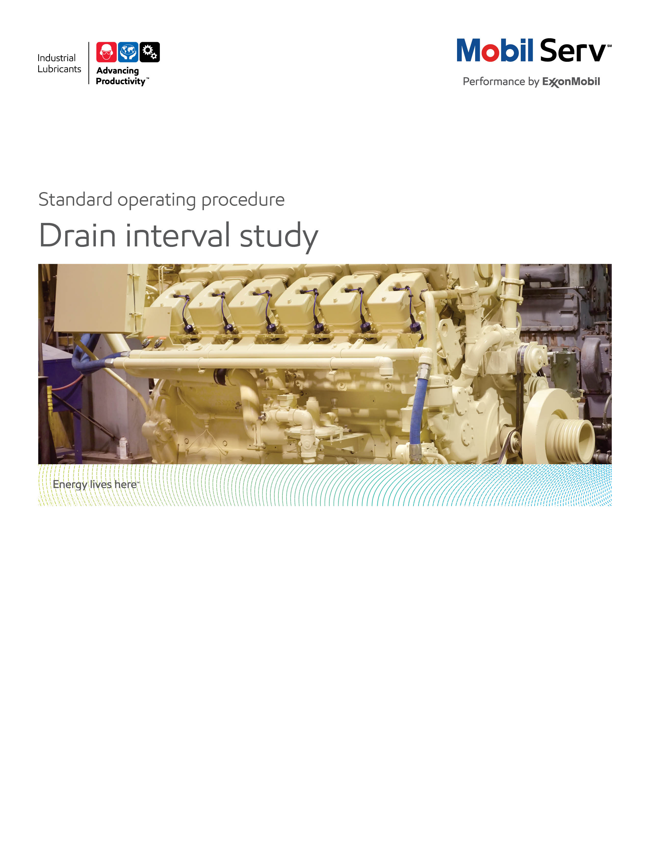



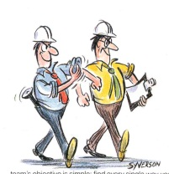

**Standard Operating Procedure** **(SOP)**

**Read all of the steps in this SOP before beginning work.** **Follow customer labor requirements (eg respect Union work)**

|  |  |  |  |  |  |
| --- | --- | --- | --- | --- | --- |
| **SOP: Extended Oil Drain Interval** | | DATE  6/2/2013 | ⌧ NEW  REVISED  ___ Number | | PAGE 1 of 14 |
| TYPICAL CUSTOMERS  Off Highway | WORK TYPE  Engine Extended Oil Drain Interval | WORK ACTIVITY (Description)  Steps to properly extend the oil drain interval for engines in Off Highway operations. | | | |
| **DEVELOPMENT TEAM** | **POSITION / TITLE** | **REVIEWED BY/DATE** | | **POSITION / TITLE** | |
| Manuel Escalante | Peru LE | Luciano Macias 6/2/2013 | | FES Supervisor | |
| Juan Carlos Otero | Colombia LE | Cirilo Hurtado | | Fleet Application Engineer | |
|  |  | Thomas A Schiff 9/3/2013 | | FES Americas Manager | |
| **PLEASE UTLIZE ATTCHED GENERAL JSA AS GUIDANCE AND, IF YOU HAVE DONE A SITE SPECIFIC JSA.**  [**http://intratta.na.xom.com/emdn/sbps/docs/safety/jsa/JSA_Mobile_Equipment_Inspection.xls**](http://intratta.na.xom.com/emdn/sbps/docs/safety/jsa/JSA_Mobile_Equipment_Inspection.xls)  [**http://intratta.na.xom.com/emdn/sbps/docs/safety/jsa/2012/Off_Highway_Construction_Account_Visit.xlsx**](http://intratta.na.xom.com/emdn/sbps/docs/safety/jsa/2012/Off_Highway_Construction_Account_Visit.xlsx)  [**http://intratta.na.xom.com/emdn/sbps/docs/safety/jsa/Mine_Site_Visit_JSA.xls**](http://intratta.na.xom.com/emdn/sbps/docs/safety/jsa/Mine_Site_Visit_JSA.xls)  **PLEASE ASSESS YOUR OWN CONDITIONS OR SPECIFIC SAFETY REQUIRMENTS AND BE SAFE.** | | | | | |
| **EQUIPMENT INDEPENDENT OF JSA DESIRED DOCUMENTATION** | | | | | |
| ⌧ COMPUTER  ⌧ MASK  ⌧ FLASHLIGHT  ⌧ SAMPLE THIEF, BOTTLES & LABELS  ⌧ RAGS  ⌧ STILL CAMERA  ⌧ VIDEO CAMERA  CHECK WITH CUSTOMER : OK TO USE OWN TOOLS OR MUST BE CUSTOMERS | | ⌧ ENGINEERING BENEFIT PROPOSAL  ⌧ PROTOCOL FOR DIESEL ENGINE OIL DRAIN INTERVAL  ⌧ SERVICE REPORT (Monitoring).  ⌧ OIL ANALYSIS REPORT (SIGNUM).  ⌧ SERVICE INSPECTION REPORT.  ⌧ MEETING DOCUMENTATION.  ⌧ FINAL - ENGINEERING BENEFIT REPORT (ESR) WITH TOTAL COST of OWNERSHIP (TCO) SAVINGS  **OTHER (SPECIFY**)  ⌧ PRESENTATION WITH RESULTS AND TCO | | | |
| **TIME ESTIMATED TO COMPLETE THIS TASK** **NUMBER OF PEOPLE TO PERFORM THIS TASK** | | | | | |
| TWO TO THREE OIL DRAIN INTERVALS TO CONFIRM FINAL “TARGETED” DRAIN (½ YEAR OR MORE.) | | 2 - 3, SHOULD CONSIDER CUSTOMER PERSONNEL | | | |
| **FREQUENCY TO PERFORM THIS TASK** **SKLLS REQUIREED TO PERFORM THIS TASK** | | | | | |
| DEPENDS ON CUSTOMER COMMITMENTS, USUALLY 1 TIME PER 2 OR 3 YEAR FOR PROCESS SECTION – ALSO DEPENDING ON CHANGES TO FLEET EQUPMENT MIX AND OR DUTY CYCLE | | ⌧ MECHANICAL APPTITUDE,  ⌧ PRODUCT KNOWLEDGE  ⌧ ENGINES, OFFHIGHWAY EQUIPMENT FAMILY, lms  ⌧ UOA INTERPRETACION SKILLS;  ⌧ FIELD CONDITIONS INTERPRETATIONS  ⌧ ENGINE CATALOG  ⌧ ENGINE PART INSPECTION  ⌧ FAILURE ANALYSIS | | | |
| **JOB COMPETANCIES REQUIRED TO PERFORM THIS TASK,** | | **TRAINING REQUIRED TO PERFORM THIS TASK** | | | |
| PRODUCT SELECTION – ENGINE APPLICATION.  OFFER EXECUTION - BASIC OFFER EXECTUION – ENGINE INSPECTIONS –  ENGINE TECHNOLOGY | | ⌧ PRODUCT KNOWLEDGE AND RECOMMENDATIONS  ⌧ EQUIPMENT APPLICATION (ENGINES)  ⌧ TROUBLE SHOOTING PROBLEMS/FAILURE ANALYSIS  ⌧ ENGINE INSPECTIONS (MID LIFE OR OVERHAUL).  ⌧ USED OIL ANALYSIS INTERPRETATION.  ⌧ FILTER ANALYSIS  ⌧ ENGINE TECHNOLOGY (IMPACT TO DUTY CYCLE, ENGINE AND OIL, I.E. TIER III VS TIER IV COMPLIANT ENGINES  ⌧ SITE SPECIFIC SAFETY TRAINING | | | |
| **OTHER RESOURCES REQUIRED OR SUPPORT** | |  | | | |
| ⌧ TECHNICAL HELP DESK ([tsc.amerias@exxonmobil.com](mailto:tsc.amerias@exxonmobil.com))  ⌧ www.mobilindustrial.com  ⌧ www.looble.com  ⌧ INSIDE SALES | | ⌧ LTS (LUBRICANT TECHNICAL SUPPORT) | | | |

**PURPOSE -** To describe the process to extend the oil drain intervals (ODI) for diesel engines used in Off Highway applications, providing value to the customer by improving the availability of the equipment.

External Offer Sheet: Placeholder

Internal Offer Sheet: Placeholder

**INTRODUCTION**

This guide is based on experiences of using Mobil Delvac engine oils in applications where it was desired to demonstrate the superior performance of the oil and or to optimize oil the drain intervals.

The commitment required by ExxonMobil and the customer's staff should not be underestimated. It is therefore imperative that proper planning and identification of the expected outcome, risks and impact on the Total Cost of Ownership, for both ExxonMobil and the customer, is completed before starting any field test.

These are suggested guidelines that can be adapted as needed in conjunction with your local Field Engineering Support team.

|  |  |
| --- | --- |
| **LOCATION** | **JOB STEPS** |
| Early stages at customer site and home office | Collect baseline data:   * Conduct a feasibility analysis using existing used oil analysis data, where available, to assess the capability to extend current oil drain intervals; this should be aligned to extend the entire preventative maintenance activates (typically not beneficial to extend the engine oil drain interval if other non-lube activities can not be extended) * Understand fleet duty cycle * Understand the engine/machine technology used (i.e. Tier III VS Tier IV based fleet). * Understand applications the fleet is operating under * Collect the predominant equipment and engine make and models being used. * See Appendix 1 - **BASELINE DATA** |
| Home office and Customer | Prepare a Benefits Proposal for ODI Extension.   * Using the information gathered to build the baseline and considering the identified needs of the customer establish the value of the benefits for the customer. * Create the initial engineering benefit proposal explaining the estimated value for the customer * Present to the customer and builder and get an acceptance * See Appendix 2 - **TARGETING DRAIN OIL INTERVALS**  and Appendix 3 - **EXTENDING DRAIN OIL INTERVALS** |
| Home office and Customer | Build agreement and teamwork with all stakeholders   * Ask the customer for the person or persons who will support the test * Work with the builder to have a consultant from their side who could * participate. * Engage the required ExxonMobil Personnel (Sales Engineer, Lab Personnel, EB Engineer, management) |
| Home office and Customer | Formalize the field test protocol:   * Include at a minimum the duration, goals/objectives, sampling procedure and definition of a successful test, responsibilities, indicators and limits. * Think through the field test with a mind to safety, your safety and that of your customer and their staff. Follow all Safety items as detailed in applicable JSA’s * See Appendix 4 - **OIL SAMPLES** **and** Appendix 5 **USED OIL MONITORING** |
| Home office and Customer | Select vehicles for trial   * All vehicles used in the trial shall have similar engine hours and have all recently entered service or been overhauled, up to 4500 hours * A minimum of five (5) matched test vehicles is recommended. There is no maximum number of vehicles that could be included in a trial. * Vehicles not representative of the average duty cycle of the fleet, operating under excessive/or light loads or with high amounts of idle time, should be avoided. * See Appendix 6 - **VEHICLE SELECTION & RECORDS KEEPING** |
| Home office and Customer | Brief all those involved in the trial   * Be sure that a MoC process is conducted to have all personnel in the customer aware of the trial * Include in the MoC Periodical communications on the scope and the results of the trial |
| Home office and Customer | Conduct and monitor the trial, leveraging a Used Oil Analysis Program and Engine Inspections  See Appendix 3 - **EXTENDING DRAIN OIL INTERVALS** |
| Home office and Customer | Collate and report the findings   * Document results of tests * Document recommendations * Document TCO benefits * See Appendix 7 for a  **Model Report on Oil Drain Interval** * See Appendix 8for a **Presentation with an overview on oil drain extensions** **extension** |
| Home office and Customer | Monitor the capability of the fleet to sustain the targeted oil drain intervals:   * Review the fleet’s duty cycle and mix of equipment to ensure that the testing is representative of the fleet at minimum annually, and or when fleet profile changes significantly to impact the capability to sustain oil drain intervals * Conduct formal Used Oil Analysis summary report annually |

**DOCUMENTING YOUR WORK** - The Oil Drain Interval procedure is used enhance the productivity of the customers by increasing the availability of the equipment and reducing the expenses related with the change of the engine oil. This activity requires developing an initial Engineering Benefit Proposal (EBP) and after study should produce an Engineering Benefit Report (ERP). This two phase documentation will highlight value to the customer in terms of Productivity, Safety and Sustainability to support the general Marketing Offer.

**TCO calculations that apply**

TCO calculations that may apply are Expenditures Reduction, Process Improvement, and Revenue

Enhancement and Asset Improvement as detailed below. The TCO Worksheets are the preferred format to include in your report. .

Expenditure Reduction - reduced lubricant purchase costs are typical expenditure savings. These result from the offset of extending oil drain intervals from the previous lube against the increased price of Mobil premium and flagship products. This also could allow the customer to plan for overhauls during a planned outage instead of an emergency shutdown. Other expenditure reduction comes from disposal costs of used engine oil. Find out how much the unit cost of disposal is and use the consumption on an annual basis. Make sure to factor in the reduced usage with Mobil premium and flagship products as they apply or have applied in time. In addition, fuel usage should be less when using Mobil Delvac 1 Synthetic Oils.

Process Improvement - the hourly wages (including burden) for personnel to perform existing tasks. As lubricant change outs are reduced, use these to determine process improvements. As lubricant usage is reduced, use the time to handle drums and the time to dispose of used lube to determine process improvements.

Revenue Enhancement - any serious abnormal engine system or lubricant condition observed may be repaired during normal maintenance and reduce the potential for downtime. “Unscheduled Downtime”, resulting in lost production and most often, scrapped parts or material.

Asset Improvement - use the customers "cost to carry" (usually 20%) inventories. This is used from the Expenditures components for example, as you reduce the quantity of lube needed, take that amount cost and multiply by the "cost to carry" to determine the Asset value.

Appendices

1. Baseline Data
2. Targeting Drain Oil Intervals
3. Extending Drain Oil Intervals
4. Oil Samples
5. Used Oil Monitoring
6. Vehicle Selection and Record Keeping
7. Model Report
8. Overview on oil drain extensions extension
9. Engine Inspections Information

**Appendices**

**Appendix 1 - BASELINE DATA**

Obtain and record for each vehicle involved in the test:

* Vehicle type, application and duty cycle
* Vehicle identification/registration number
* Engine type, make, model
* Engine configuration and serial number
* Engine power rating
* Engine sump size and filtration details
* Total Engine Hours
* Hours since last Overhaul
* Average annual hours of operation
* Air Filters type, make, model
* Oil filters type, make, model
* Oil pressure
* Real consumption of oil (Changes / Top-Off)
* Real consumption of fuel
* Filter service intervals. Filter supplier should make the final service recommendation
* Oil sampling method and frequency (Best Practice: engine oil sampling valve)
* Engine Oil Leaks
* Engine / Oil / Coolant temperature record
* Conduct a formal review of the UOA history
* Collect data about recent problems in the fleet
* Records of fuel quality



**Appendix 2 -** **TARGETING DRAIN OIL INTERVALS**

Many engine builders have their own guidelines for running field trials and these should be sought out and adopted as the case may be. If the trial is likely to take the unit outside of the operating and or service parameters specified to by the builder then consultation with the builder or their authorized representative is essential prior to starting the trial to avoid any conflict in terms of warranty ownership.

Agree upon a realistic oil drain interval with the customer. The final target oil drain interval should be based upon the following parameters:

* OEM recommendations: consultation with the builder or their authorized representative is essential prior to starting the trial.
* Customer requirements: due to production constrains or equipment availability the customer would desire to optimize or extend the ODI recommended by the OEM.
* Type of Maintenance: errors and omissions in routine preventive maintenance practices will affect oil condition, resulting in increased engine wear.
* Application: Environmental and operational factors (% idling, slopes, altitude, consumption, etc.). that contribute directly to increased wear and/or oil condition degradation.
* External Contamination: Fuel, water, glycol or anything else getting into the engine lubricating system from the outside, accelerating wear.
* Fuel quality.

**Appendix 3 -** **EXTENDING DRAIN OIL INTERVALS**

Next recommendations are based on ExxonMobil experience and having on account the guidelines of some OEMs to extend the drain oil intervals:

* Proceed beyond the manufacturer's recommended oil change period cautiously in incremental steps of at most 20% of the period recommended by the manufacturer (**R**). This incremental period is called XODI in the chart below.
* Determine that wear rates and oil condition are satisfactory at the **R** interval.
* Extend from the **R** recommended period to **1.2 x R** hours.
* Stay with a **1.2 x R** period for at least 3 changes and closely monitor the Used Oil Analysis.
* If the wear rates and the Oil condition is OK proceed again increasing the drain interval at most 20% of the period recommended by the manufacturer (**R**).
* Consult Field Engineering Supervisor / Field Engineering Advisor for their approval

The chart below presents the process to extend the drain oil intervals according with information presented above. This chart is a guide and permanent evaluation of the conditions of the equipment, the oil and the operation should be performed during all the process.

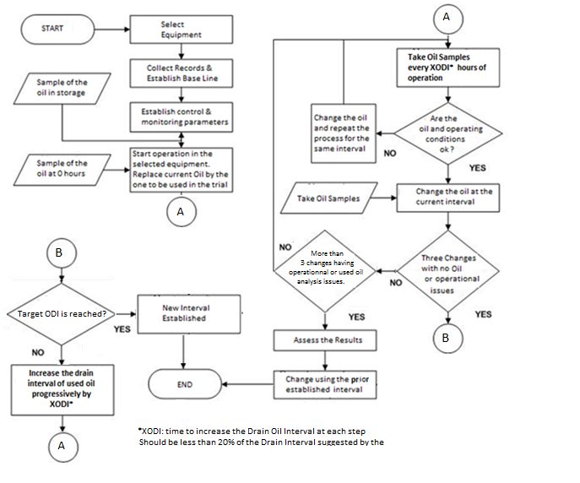**Oil Drain Interval Optimization Process**

**Appendix 4 -** **OIL SAMPLES**

There are three categories of oil samples involved in evaluating an oil change interval:

1. Baseline Samples: These are the samples taken before to start the ODI extension process. This determines the current conditions of the engines and mainly the baseline to compare future results.
2. Samples at increased Intervals (XODI in the chart above): Taking samples at less than the recommended oil change interval is essential to monitoring the oil degradation process. This will allow you to determine a trend line for wear accumulation and any external contamination entry.
3. Samples at Oil Change: Test results from the samples taken at the time of each oil change will indicate the final levels of oil degradation and wear accumulation. These results, along with the shortened interval sample results, will be evaluated to establish the optimal oil change interval for the engine.

See in the next chart an example on when to take each one of the samples in a case of engines with a 250-hour drain interval where we want to extend it up to 400 hours:

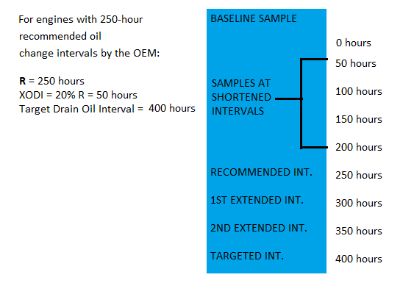



**Appendix 5 - USED OIL MONITORING**

Used oil condition monitoring is an essential component of the process. The greater the severity of the trial, the greater the need to maintain a rigorous oil monitoring regimen.

An approved ExxonMobil Used Oil Analysis laboratory should be used to analysis the oil samples. Test slate should include at a minimum; viscosity, water, oxidation, metals, fuel dilution, soot, & TBN. (Take into consideration that Customer may use different UOA Laboratories and the test results could be expressed in different units).

Samples should be taken on a regular basis according to the periods established.

*Baseline samples* provide the frame data to evaluate the conditions of the engine and the performance of the oil. The results of the baseline samples must indicate that the engines are in good condition and that there is no problem with the oil. Any alert in the oil condition or engine wear must be attended prior to proceed with the oil drain extension.

Please check the file attached. Each one of the conditions listed should be assessed in the baseline samples and any problem corrected before to proceed with the drain interval extension



*Samples at shortened intervals* are taken specifically to track the trend of the oil variables during the period between oil changes. It is important for the trial to build the trend of the most critical variables. Critical variables will be decided jointly with the customer depending on the operation conditions. For example:

1. If the equipment is working in a dusty environment and the silicon has been a frequent alert in the Used Oil Analysis program, then the trend of the silicon in the samples at shortened intervals must be closely tracked.
2. If the engines frequently work extended periods with low load level, it´s possible that the lubricant is contaminated with fuel and the viscosity of the oil could decrease. If that is a condition the fuel dilution and/or the oil viscosity should be tracked.

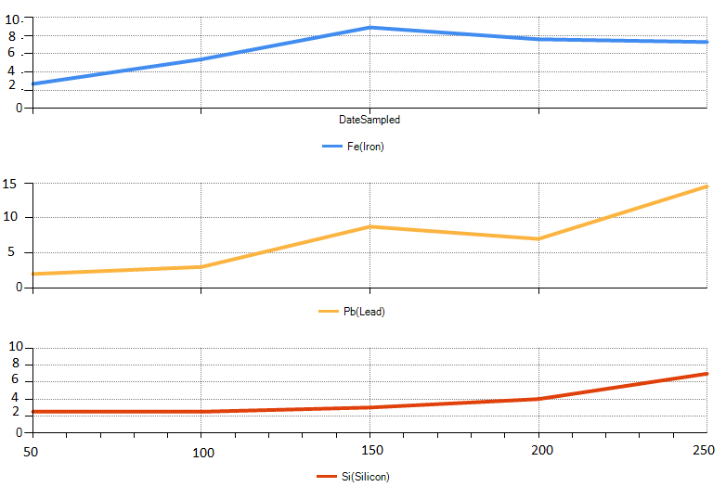Other variables to be studied and considered to be tracked in the samples at shortened intervals are TBN, oxidation, wear (mainly iron, copper, lead and aluminum) and soot. These are not the only variables to follow, as it was stated above that the variables would depend on the assessment of the operation.

The next chart presents the trend for the samples at shortened intervals (+ 50 hours) for silicon, iron and lead (ppm). In this case is normal that the level of the wear metals grow as they are being accumulated with the time.

This kind of graphics make easy to detect not only peaks or inflection points but also correlations among different variables and enable you to perform a better analysis.

Among the samples taken at shortened intervals it is important to verify if:

* The trends are according with the expected design.
* The absolute values are within the defined limits.
* There is a pattern when the values are time weighted for the selected variables.
* There is a pattern for all the samples for the selected variables at the same times of operation.
* There are inflection points for any of the variables at consistently the same time.

For any variable out of the defined limits, or inflection point consistently found, or any correlation existing among the variables, a detailed analysis must be done and the corrective actions and decisions must be taken.

The samples analyzed at the shortened intervals are useful to detect if during the oil change interval some condition could make difficult to reach the targeted interval.

*The samples at the oil drain interval* will provide the information to determine if the target period is feasible, if not, or even if a larger interval is possible. These samples are going to support the recommendation for an extended oil drain interval in the long term.

All variables are critical as any of them failing would lead to reduce the optimum interval. It’s not supposed that 100% of the oil samples at the targeted drain oil interval will be within the limits but you will like that, at least the number of acceptable samples will be the same that you used to have with the drain interval recommended by the OEM.

Besides the verifications and correlations done for the samples taken at shortened intervals you can also make the next analysis for the samples taken at drain intervals:

* Scatter Plots: enable you to easily see correlations between different variables. You can detect the real cause of the wear, or if the condition of the oil is leading some abnormal condition in the engine. See below some suggested scatter plots, but there are many more that could be applied depending on the operation conditions:
* Silicon vs. wear metals
* Soot vs. wear metals
* Viscosity vs. wear metals
* Viscosity vs. Oxidation
* Oxidation vs. TBN

Graphics below present examples of scatter plots for Soot vs. Iron, and TBN vs. Oxidation. The higher the level of soot the higher the iron wear. The higher the oxidation, the lower the TBN. Fortunately in both cases most of the values of the four variables are within the required limits and most of the point population is concentrated in the desirable zones.

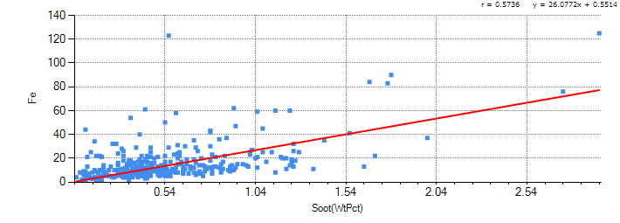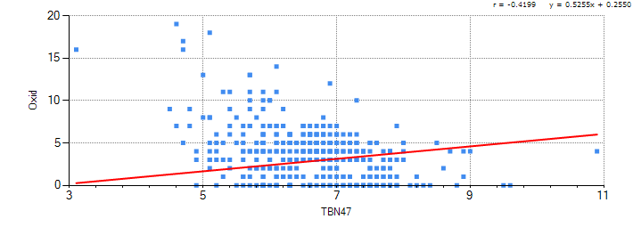

* Standard Deviation and Distributions: a distribution analysis will enable you to decide if the extended oil drain test is statistically successful. Not all the samples have to be within the designed parameter, but most of they should. You can define how many samples should be within two (three, four, five or six) standard deviations to consider the test acceptable. This decision could be based in the situation existing before of the oil drain interval test. The variables to be measured with these criteria are those where more alerts were present during the process.

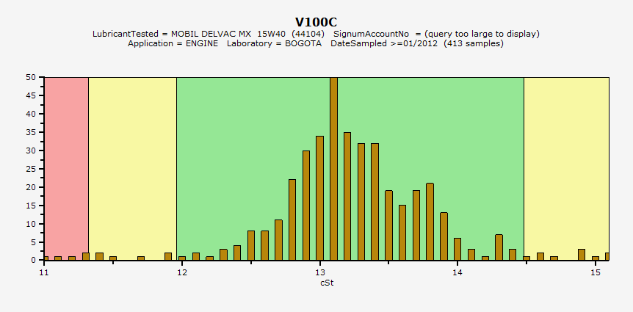The next frequency graphic present the distribution of the viscosity in a group of samples taken to different engines in a period of three months. There are unacceptable samples at both sides as the viscosity could fail at high and low limits. 1.25% of the samples failed due to low viscosity. It could be, or not, acceptable depending on the initial conditions.

There are some other variables as the metals wear that would fail only at the higher end. The distribution graphic for this variables looks like the next example done for the same engines for iron wear.

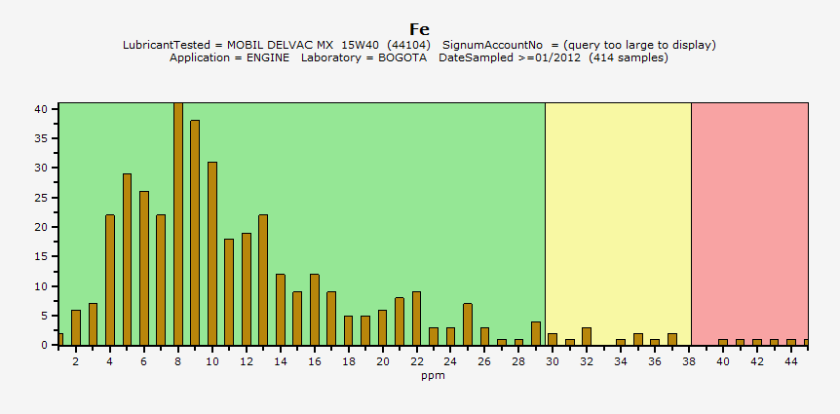

* Time weighted analysis: you can compare the values for some variables at different drain intervals using the information obtained during the process. This information is useful to predict what could be the maximum interval and if the risks involved are worth to try to continue increasing the oil drain interval.

Once the drain interval has been established, even if the target is or not reached oil analysis may not be discontinued. At the discretion of the Field Engineer Supervisor / Field Engineering Advisor and/or customer, sampling at shortened intervals may be practiced to guard against fuel dilution, dirt ingestion or coolant contamination. Sampling at "end of drain" is highly encouraged or mandatory as per the discretion of the Field Engineer Supervisor / Field Engineering Advisor.

**Appendix 6 -** **VEHICLE SELECTION & RECORDS KEEPING**

Vehicles used in the trail should be representative of the fleet’s machines with respect to engine make, model, duty cycle, emission compliance, age and application

All vehicles used in the trial shall have similar engine hours and have all recently entered service or been overhauled, up to 4500 hours. If the fleet contains a number of older or high hour vehicles that will also operate on the test oil for fleet management reasons, they should be in good operating condition with a good, well-documented service history.

A minimum of five (5) matched test vehicles is recommended. Five matched vehicles are desirable so that if a unit is withdrawn from service or gives uncharacteristic test results then other units are available to continue the trial. There is no maximum number of vehicles that could be included in a trial. Note: The more vehicles involved in the test the higher the burden on the customer and the more data will make it challenging to maintain proper control of the testing.

Vehicles not representative of the average duty cycle of the fleet, operating under excessive/or light loads or with high amounts of idle time, should be avoided.

Record keeping throughout the evaluation needs to be meticulously maintained. Leave absolutely nothing to memory or guesswork. The records need to be easily accessible by Mobil for trial monitoring purposes and should include the following:

* Date and unit hours when the units are converted to the test oil
* Periodic update of the unit hours
* Date and unit hours of each oil change
* Date, unit hours and quantity of oil added as top-off
* Date and unit hours when used oil samples are taken
* Date and unit hours when the oil filter is changed
* Date and unit hours when vehicles are removed or added to the test fleet
* Detailed fuel consumption records

**Appendix 7 - Model Report on Oil Drain Interval extension**



**Appendix 8 - Overview on oil drain extensions extension – It is labeled EM Confidential, need de-classify or refer to it on Inside Sales**



**Appendix 9 - ENGINE INSPECTIONS**

**(**See details following the next link [Engine Inspections](http://intratta.na.xom.com/emdn/sbps/technical/engg_services/pes/pes%20cd/references/pes%20tools/inspection%20program%20overview/diesel%20engine%20inspection.htm) ).

Extending drain oil intervals should not affect the life of the engines. Period for overhauls estimated by the OEMs should be reached and surpassed even extending the drain oil interval. Otherwise extension benefits would be reduced.

A way to ensure that the life of the engines is reaching the designed periods is performing engine inspections when some of them reach the time for overhaul.

Engine Inspection is a procedure intended to determine the conditions of an engine and the performance of the engine oil. Most engine components are discussed individually including how they can be inspected for cleanliness and wear.

**Required Tools**

Camera

Good Portable Light

Borescope (if it is available)

Clipboard & Checklists

**Procedure**

Any good engine inspection should include all the background data or specifics about the engine

Photographs should be taken of all critical parts, the engine operating conditions and the reason for being overhauled should be known. Information to Obtain:

* Account name
* Account location/address
* Engine manufacturer
* Engine model
* Engine serial number
* Type of service
* Load factor
* Distance or hours since last overhaul
* Last overhaul - Major or Minor
* Who did last overhaul and why it was done
* Engine oil used and how long
* Engine oil consumption
* Normal oil change interval
* Oil filter make and model used and change interval
* Oil pressure before overhaul
* Fuel consumption
* Type of fuel, typical sulfur content
* Reason for engine overhaul
* Engine performance just prior to overhaul
* Air intake system condition
* Was engine smoking and if so what color
* Engine History

The engine serial number is very important because during production, changes can be made to certain model engines that could be vital to know at overhaul. Changes like bearing material or certain accessories like the air compressor could be different during the production run.

**Inspect Engine parts**

Inspect the following engine parts for cleanliness:

* Air Intake System

* Valve Cover and Valve Deck

* Crankcase Pan

* Oil Screen and Oil Pump

* Piston and Rings

* Combustion Chamber

* Intake Ports (2-CYCLE)

* Turbocharger

* Valves and Valve Stems

Inspect engine parts for wear

The following engine parts should be examined for wear, either visually or measured with either a caliber or a micrometer:

* Main Bearings

* Cylinder liners

* Pistons and rings

* Connecting rod bearings

* Cams

* Valve Guides, Stems, and Seats

* Rocker Arm Pads

* Push Rod Ball and Socket

* Fuel Injectors

* Oil pump gears

* Turbocharger

Inspecting an engine at overhaul is like being a detective. You have to collect much data, observe the facts, and put all the pieces together. Remember, most performance problems are really due to mechanical or operational factors. The oil is VERY SELDOM at fault! Through an accurate and complete engine inspection, you can prove the oil was NOT at fault and gain the respect of the customer through conducting a safe and thoroughly professional inspection.

**Analyzing Findings – Guidelines & Troubleshooting**

Engine cleanliness will be dependent on the following factors:

* Engine oil quality
* Maintenance procedures
* Engine/equipment operator
* Operating conditions
* Load factors and type of service

**Engine wear**

There are 3 main types of engine wear that occur inside an engine:

* Abrasive wear: This is caused by the dust and dirt that is carried into the cylinders through the intake system.
* Metal-to-metal contact wear: This type of wear cannot be avoided entirely. The rate of wear from this depends on a large degree on the suitability of the engine oil, the operating temperature and correctly assembled parts.
* Corrosive wear: This type of wear results from water from leakage or condensation and a combination of acidic end products of combustion.

A report presenting the condition of cleanliness and wear of the inspected engine should be prepared and shared with the customer supporting the benefits derived from the oil drain interval extension.