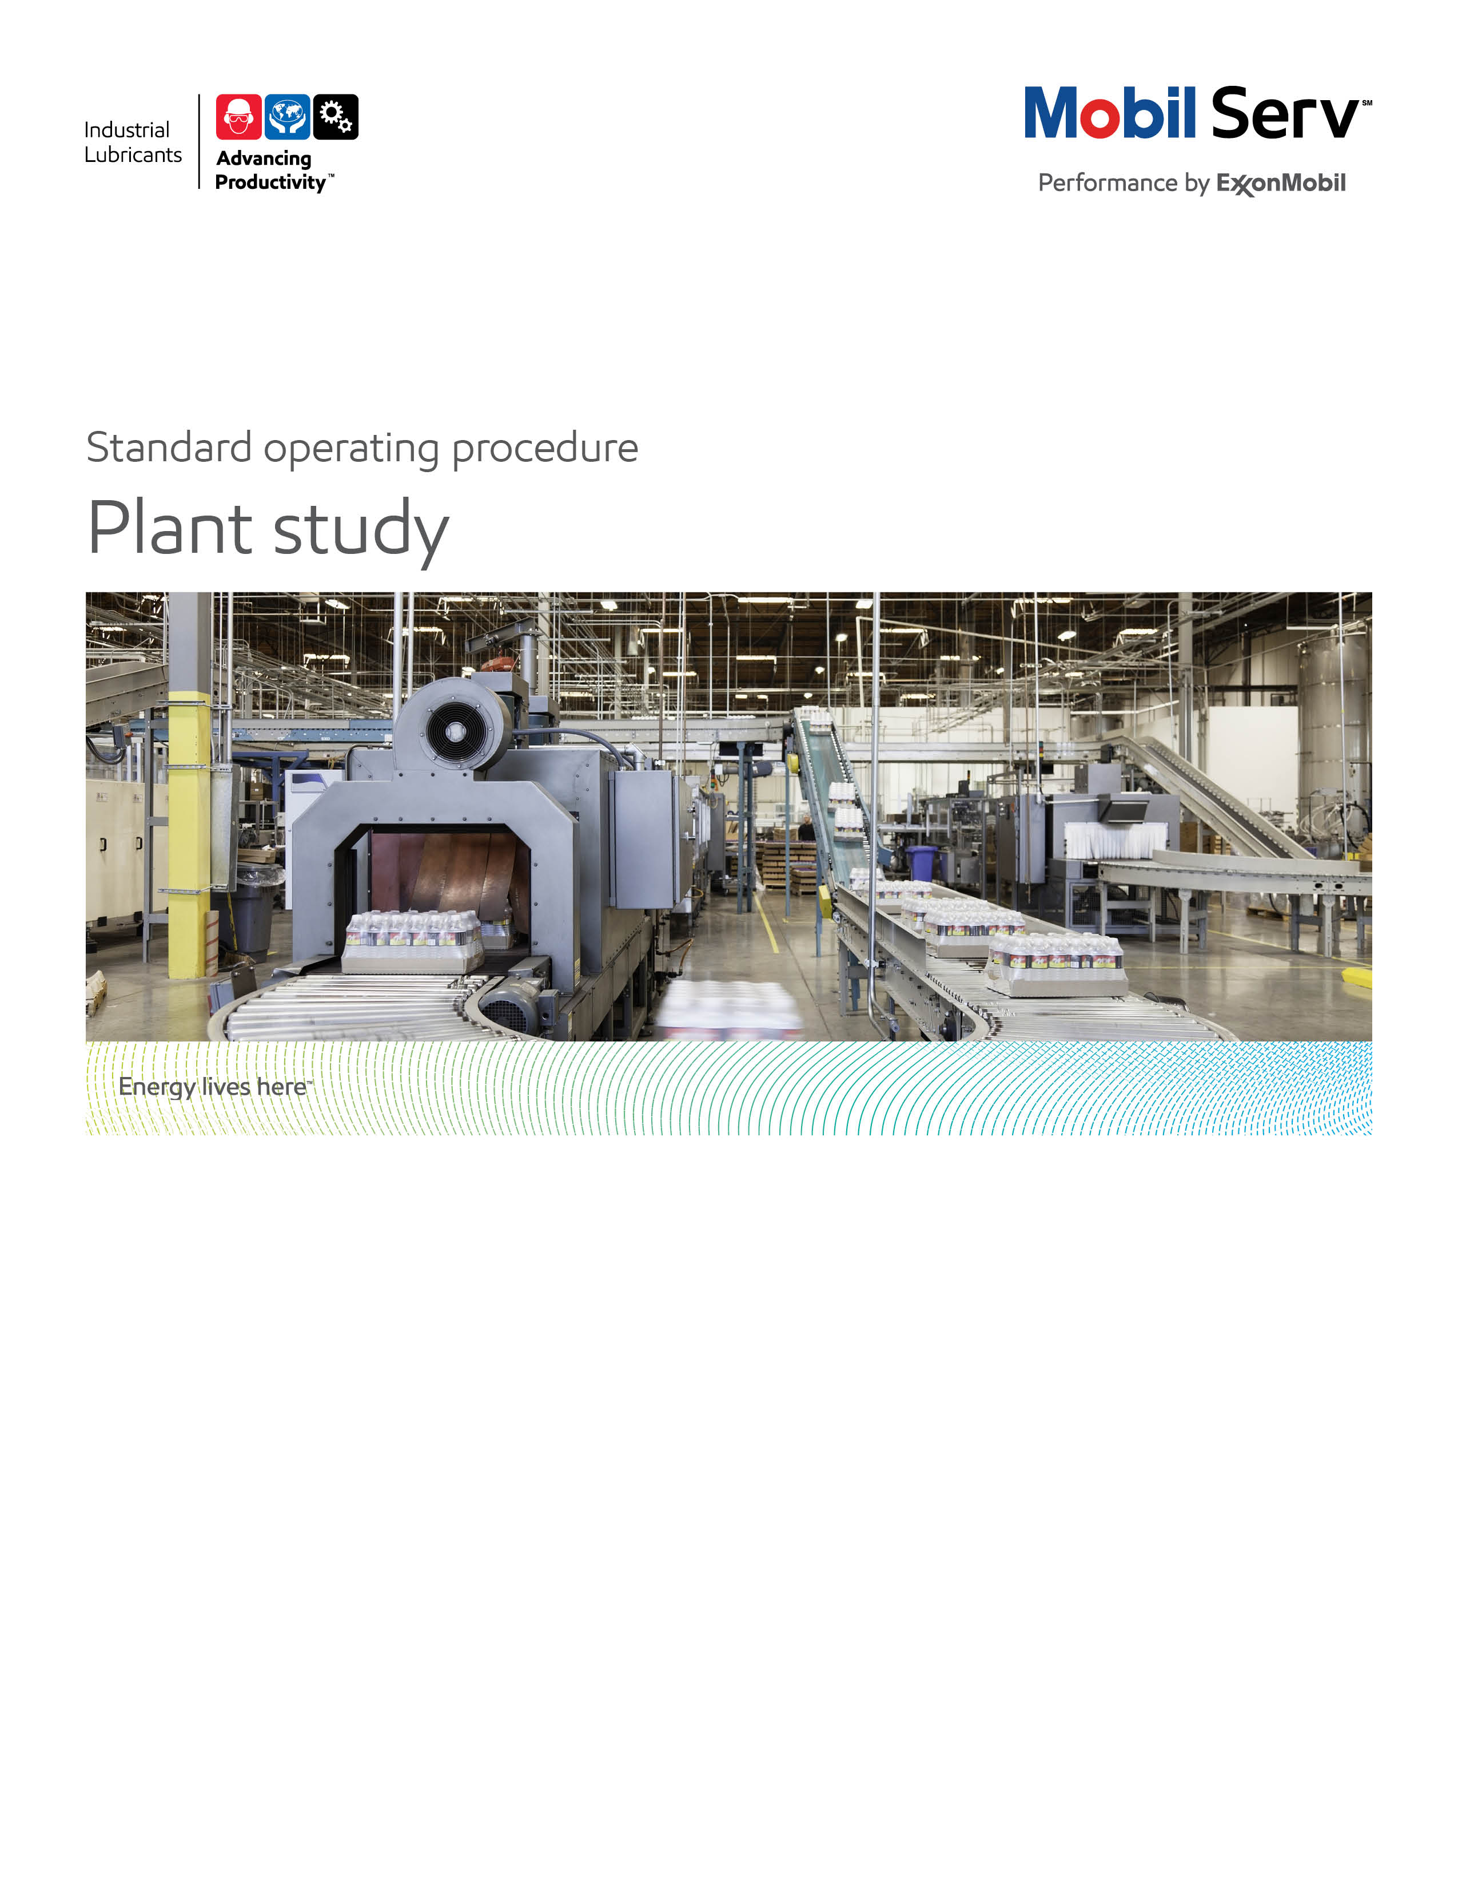


Standard Operating Procedure (SOP)
Read all of the steps in this SOP before beginning work. Follow customer labor requirements (eg respect Union work)

SOP: Lubrication Assessment  (Called Lubricant Assessment for Existing Customers and Called Plant Study for Potential New Customers) |  | DATE  September 17, 2015 |  NEW  o REVISED  ___ Number |  | PAGE 1 of 3
TYPICAL CUSTOMERS  All PES and Major Industrial Customers | WORK TYPE  Lubrication Assessment | WORK ACTIVITY (Description)  Inspection/Evaluation of existing/potential customer’s lubrication program procedures and practices
DEVELOPMENT TEAM | POSITION / TITLE | REVIEWED BY/DATE |  | POSITION / TITLE
Marianne Duncanson | Sr. Field Engineer | Gilles Delafargue |  | Global FES Advisor
 |  | Tom Schiff |  | Global FES Manager
PLEASE UTLIZE ATTCHED GENERAL JSA AS GUIDANCE AND, IF YOU HAVE DONE A SITE SPECIFIC JSA.
PLEASE ASSESS YOUR OWN CONDITIONS OR SPECIFIC SAFETY REQUIRMENTS AND BE SAFE. http://intratta.na.xom.com/emdn/sbps/docs/safety/jsa/JSA_Lube_Survey_General_Plant.xls
EQUIPMENT INDEPENDENT OF JSA DESIRED DOCUMENTATION
 CLIPBOARD OR IPAD   IR GUN/IR CAMERA  FLASHLIGHT   LINK FREE RAGS  IPad with Site Study App   CAMERA  CHECK WITH CUSTOMER : OK TO USE OWN CAMERA OR MUST BE CUSTOMER’S CAMERA  CHECK IF EQUIPMENT NEEDS TO BE INTRINSICALLY SAFE |  | - DAY OF – LUBRICATION ASSESSMENT QUESTIONNAIRE, BLANK ASSESSMENT FORM OR ELECTRONIC SPREADSHEET  - FINAL - ENGINEERING SERVICE REPORT (ESR) WITH TOTAL COST of OWNERSHIP (TCO) SAVINGS  - OTHER (SPECIFY)  - PRIOR LUBRICATION ASSESSMENTS AT CUSTOMER TO CHART PROGRESS  - ASSESSMENT ATTACHMENTS AS APPROPRIATE
TIME ESTIMATED TO COMPLETE THIS TASK NUMBER OF PEOPLE TO PERFORM THIS TASK
4 HOURS FOR OFFICE BASED CUSTOMER INTERVIEWS AND 4 TO 8 HOURS FOR ON-SITE WORK, 1 DAY FOR ESR CREATION |  | 1 -2 QUALIFIED EXXONMOBIL/DISTRIBUTOR PERSONNEL
FREQUENCY TO PERFORM THIS TASK SKLLS REQUIREED TO PERFORM THIS TASK
- FOR POTENTIAL NEW CUSTOMERS (CALLED A PLANT STUDY FOR NEW BUSINESS), THE ASSESSMENT IS TYPICALLY ONE EVENT BUT FOR SOME POTENTIAL CUSTOMERS MAY TAKE MULTIPLE ASSESSMENTS.  - FOR EXISTING PES CUSTOMERS, TYPICALLY CONDUCT ONE TO FOUR TIMES PER YEAR |  | - MECHANICAL APPTITUDE  - LUBRICATION APPLICATION AND SUFFERING POINT IDENTIFICATION  - PHYSICAL ABNORMAL CONDITION DETECTION (TEMPERATURE, NOISE, SMELL, VIBRATION)  - OBSERVE AND COUNT OIL LEAKAGE; DROPS PER SECONDS
JOB COMPETANCIES REQUIRED TO PERFORM THIS TASK, |  | TRAINING REQUIRED TO PERFORM THIS TASK
- PRODUCT AND PRODUCT APPLICATION KNOWLEDGE  - CUSTOMER ROTATING EQUIPMENT KNOWLEDGE  - SUFFERING POINT IDENTIFICATION  - TOTAL COST OF OWNERSHIP  - OBSERVATIONAL, ANALYTICAL, AND COMMUNICATION (ORAL/WRITING) |  | - OTJ TRAINING TO UNDERSTAND INDUSTRY SUFFERING POINTS; PARTICIPATE IN AT LEAST ONE ASSESSMENT WITH EXPERIENCED FIELD ENGINEER  - SOP HYDRAULIC INSPECTION, LEAK DETECTION STUDY, STORAGE AND HANDLING STUDY, BEARING INSPECTION, GEAR INSPECTION, COUPLING INSPECTION, ROOT CAUSE ANALYSIS, LUBRICANT ANALYSIS PROGRAM STUDY  - APPRORPRAITE 3RD PARTY SITE SAFETY TRAINING  - ENTRY LEVEL TRAINING

PURPOSE - To conduct an effective lubrication assessment to provide value-added suggestions for improvements in lubricants and lubrication practices. To identify opportunities where Mobil premium products can help improve equipment reliability. To act as a springboard for further Mobil engineering services.

For potential customers, we call this service “Plant Study for New Business”. Typically a Sales Advisor Field Engineer team and or Distributor Sales Representative/Distributor Lubrication Engineer work as a team to conduct the study. The assessment serves as a demonstration of our capability to deliver customer value. Typically the EM Sales Advisor/Distributor Sales Representative (with Field Engineer/Distributor Lube Engineer support) takes the output of the assessment to develop a major sales proposal.

For existing customers (typically PES and Major), we perform lube assessments in order to help customers meet their business goals. These assessments can address the customer’s overall lubrication program to look for improvement opportunities or they can be target at a specific customer suffering area. Typically the Field Engineer/Distributor Lube Engineer take the output of the assessment to create an Engineering Service Report to communicate the value generated by following the recommendations formed from the insights/findings of the assessment.

As with all services, strong customer alignment/commitment will result in the greatest acceptance of value.

Overview
When the commitment from the customer has been confirmed, the Field Engineer, in some cases with the assistance from the Sales Advisor, will have to conduct detailed plant studies. It may be a study of all plant equipment and processes, or further details on the opportunities identified in the Preliminary Study, or on specific areas of the agreed PES objectives. During the course of the study, the Field Engineer may uncover additional suffering points that could lead to further benefits. If of sufficient magnitude, they should be included in the lubrication study report.

Before conducting the detailed plant study, proper access for the Field Engineer to all parts of the plant has to be arranged. If there are limitations imposed by the customer, they should be clearly defined. These may include restricted access to certain departments; departments which will not be included in the initial stage; competitive products which due to trade relations or other reasons are to be continued in service, etc..

The Field Engineer then arranges his/her time schedule and routing with the customer to make the study. By using the Plant Analysis Workbook (Plant Analysis Workbook Link), the Field Engineer will investigate the Ten Phases of Lubrication, covering the present practices or baseline conditions, possible recommendations for obtaining improvements and benefits that will result.

Before focusing on the objective areas, the Field Engineer may want to have a tour of the plant to get familiar with the production processes and get knowledge on the key equipment used. In doing so, he will be able to build up working relationship with the plant personnel.

Use the information on 'Identify Suffering Points' to get the details from the plant personnel. Meet and talk to as many plant personnel as possible. Experience indicates that shop floor personnel are those who have the most knowledge of what is going on and are important sources of information. Many of them have formed opinions on lubrication or maintenance issues. It is important to recognize their opinions but if their opinions can be detrimental to our efforts, strategy needs to be developed to convert them. Be sure to check with plant supervisory staff that it is acceptable to contact the shop floor staff directly.

External Offer Sheet: Pending
Internal Offer Sheet: Pending

LOCATION | JOB STEPS
Home office | - Prior to meeting establish expectations with customer  - Lubrication Assessment is intended to identify high level opportunities for improvements in lubrication practices or specifically target a suffering area (high repair rate, high lubricant usage, etc.)  - It will provide examples of areas that can use further detailed investigation and engineering services  - The Assessment report will include suggested action steps along with cost/benefit analysis  - Reviewing practices using the questionnaire is a half day meeting  - Plant walk-through takes most of a day, depending upon the size of the plant  - Ensure proper personnel are invited to meeting  - Maintenance and/or reliability manager and supervisors  - Maintenance and reliability engineers  - Purchasing contact  - Sustainability contact (if applicable)  - SSHE contact  - Lubrication technicians  - Ensure proper personnel are available for plant inspection/interviews  - Reliability or maintenance engineer  - Lubrication technician  - It is also good practice to bring along one other ExxonMobil (EM) employee or distributor representative if only one plant representative is available  - It is imperative that the Assessor (s) is accompanied by at least one representative of the plant  - Discuss Assessment job responsibilities – typically assessor (s) will record findings, take pictures, will obtain equipment temperatures and oil samples as needed with customer assistance as needed.  - Every picture should be identified preferably in two ways  - Picture number  - Take picture of equipment number prior to taking picture of equipment or Assessment observation  - Every oil sample will be labeled to capture; data, equipment number and name and oil in service  - Customize lubrication Assessment questionnaire and Assessment form for the plant or industry type  - Use the EM IPad App as the standard for collecting data  - Print copies of questionnaire and Assessment forms  - Phone discussion with customer about Safety, especially potential specific hazards we may face during the plant inspection, for anticipation / preparation (such as specific PPE to use , items to include in the JSA, etc …)
Customer Office | - Review questionnaire with customer (select the right contacts from maintenance, reliability, engineering, procurement, storeroom, etc.)  - A good practice is to have the lead customer contact read the items aloud and lead the discussion. That allows the Assessor to enter ratings and comments directly onto the form on the assessor’s laptop  - Identify suffering points to observe during the walk-through  - Review specific hazards and protective actions to take during the plant visit.
Operating Units | Conduct in plant assessment to verify /confirm the insights from the customer interviews and/or look for other improvement opportunities  Sign in to operating unit  - Inform operators of purpose of Assessment  - Ask operators of any safety issues  - Ask operators about any bad actors (equipment that breaks frequently/repeatedly), leaks, overheating, vibration, lubrication problems, any area where changes in sight glasses, lubrication or sampling points could make their jobs more efficient or effective  Observe conditions in operating unit  - General impression  - Safety first! Watch for hazards outlined in the JSA  - Look for general cleanliness including oil spills, reservoir tops clean, sight gauges and oil tags readable  - Look for obvious signs of contaminants i.e. steam leaks, dust, wash down water, process leaks  - Are equipment identification numbers readable  - Is all equipment tagged with lubricant type and grade  - Oil cabinets strategically located  - Drums and dispensing containers are not open in the units  - Equipment specific observations  - Safety first! Watch for hazards outlined in the JSA  - Hydraulics – perform a sample number of equipment inspections in each of the main operating areas by equipment type (typically one to five). Use the appropriate equipment inspection SOP as a guide. Check if Mobil DTE 10 Excel can provide energy savings  - Electric Motors – Use IR gun/IR camera to check inboard, outboard and casing temperatures. Typically temperatures greater than 27C (50F) above ambient needs to be alerted. Check for noise. Look for debris that obscures fan intake. Sight glasses should be clean, clear and filled to the right level. Fittings should be different than general grease fittings. Check to see if fittings are clean and do not have excess grease. Grease discharge plugs should be piped away from under the coupling guard or should be fitted with a relief fitting. Visually check condition of belts and pulleys for noise, slippage, vibrating - but do not touch.  - Gears – Use IR gun/IR Camera to check temperature of input, output bearings and gear case. Note location of sample point. Sight glasses clean, clear, accessible and marked with start and running oil levels. Check differential pressure (dp) on filters if on circulating system. Check oil cooler (if applicable) for oil and water temperatures in/out). A differential temperature (dT) for cooling water great than 5C (10F) indicates the cooler is performing well. Note breather type. Remove breather or filler cap, check for rust. Check if there is a good seal around inspection cover. Observe oil color and foam in sight glass or oil level stick. Check for leaks.  - Turbines - Use IR gun/IR Camera to check temperature. Note location of sample point. Sight glasses clean, clear, accessible and marked with oil level. Check dP on filters if on circulating system. Ask about filtration type and micron rating. Check differential temperature across coolers to see if coolers are effective. Observe type and manufacturer of controls. Check that oil level is visible in governor by shining flashlight through bullseyes.  - Cooling towers, Oil bath filters and remote access – These are some of the areas that can show the most improvement due to inaccessibility. There are often low oil levels, visible debris, obscured sight glasses. These open up opportunities for extended drains and better equipment protection using synthetic lubricants.  - Large lubricant reservoirs – check that IR temperature corresponds to temperature on gauges, record breather type, check for oil vapor discharge through vents, check that sight gauges are easily visible, ask if there have had to be emergency deliveries, look for rust under breather or filler cap, check sample point. Check for any foam on top of oil level by safely looking in the reservoir from a top inspection access plate. Check the drain oil from the bottom oil drain from the reservoir to check for sludge/water. Use a “sludge judge” as another means to check for dirty reservoir bottom (Link). Do not break the plane. Check for any condensation on top of inspection access plate / top of reservoir as a suffering point that is remidied by forced reservoir ventillation.  - Compressors –  - Check differential pressure across filters – high dP causes loss of compressor efficiency. Look for rust, holes or cracks, filter element clogged or missing, exposure to contaminants (sand blasting, exhaust stacks, steam vents, welding blowers, etc.), no oil in oil bath filters.  - Check temperature with IR gun.  - Intercooler fins should be free of debris so that the tube within the fins can be clearly seen.  - Check that air intake piping is not cracked, broken or re-welded and has gaskets in flange fitting.  - If using city water for cooling, propose use of a closed -loop system, ensure water is clear and that water temperature out of the compressor at least 45 C (110 F)  - For Reciprocating compressors, check discharge temperature at each stage. Temperatures over 175 C (350 F) usually indicate a problem. Temperatures over 150 C (300F) are a suffering point for mineral oils, solved by Mobil Rarus 827/829.  - Check that automatic lubricators on reciprocating compressors are operating correctly. Offer to conduct a feed rate study  - Couplings – ensure coupling guards are in place. Observe and grease slingage on the ground. Ask how Couplings are maintained and lubricated. Note any opportunities to use Mobilgear SHC 22M or 46M in couplings that require long intervals between inspections.  - Bearings - observe seals for greased bearings and general condition. Look for grease piles under the bearings as a sign of over lubrication. Take temperatures and alert any above 80 C (175 F). Observe any leaks for oiled bearings and determine root cause.
Warehouse/ Lube Room | Inspect indoor lubricant storage  - General impression  - Warehouse is clean and well organized  - Area is temperature and humidity controlled  - Drum tops are clean  - Drip pans or other containment protect floor from spills  Inspect parts and equipment storage  - General impression  - Evaluate if they have equipment storage with proper rust prevention and vibration avoidance (e.g. equipment on vibration absorbers and rotate equipment shafts)  Inspect failed parts  - General impression  - Look at metal dumpsters for failed equipment examples and probe to understand failure modes  - Question if the Inventory First In First Out (FIFO) method is used to use / manage lubricant stocks  Storage & Handling Study SOP Link
Outdoor Lubricant Storage | Bulk Storage  - General impression  - Follow storage & handling study SOP guidelines  Storage & Handling Study SOP Link
Lay-Down (Part Storage) Yard | Inspect long term equipment and component storage and failed parts  - General impression  - Follow rust prevention/equipment storage guidelines  Rust Prevention Actions for Plant Equipment
Lubricator Carts | - Observe types of containers for proper oil label  - Observe types of containers for preventing ingression of contaminants (are they sealed)  - Are containers dedicated by product  - General note on housekeeping of containers
Maintenance Office | - Check if lubrication survey is up-to-date and easily accessible  - Maintenance manuals and MSDS are available  - Key Performance Indicators are visible and known within maintenance organization; Leaks, Temperature Alerts, Oil Usage, Oil Samples/Alerts, Tank/Tote Cleanliness.
Follow Up Services | - Mobil Hydraulic Inspection  - Mobil Storage and Handling Study  - Mobil Progressive Gear Inspection  - Establishing an Electric Motor Greasing Program presentation  - Energy Assessment  - Mobil Leak Detection Study  - Mobil Compressor Air Leak Detection Study  - Mobil Compressor Feed Rate Study  - Mobil Rust Preventive Survey  - Integrated Lubrication Service oil reclamation service  - Integrated Lubrication Service equipment flushing services  General note on housekeeping of containers  Typically review with your key customer contacts the print out or email of IPad App input/findings/initial recommendations before leaving the customer site. Gain understanding of the cost/benefit of your recommendations to use in the major sales proposal or engineering service report. Gain initial alignment that your findings and recommendations/solutions generate the value you determine from your customer review.  - Collect name and phone numbers of key maintenance operators on site for further fluent site communication.
Office | Complete the major sales proposal (for Plant Studies for potential new customers) or Engineering Service Reports (for Plant Assessments for existing customers) using Mobil Serv 3D Report Writer.  A good practice is to use a spider diagram to show the “as is” customer situation versus the “to be” you will propose (you may use the model available via  Plant Study/Assessment Tool Example 1
Customer | - Present Major Sales Proposal with key customer contacts to gain the customer’s business; if awarded business work with customer on recommendation implementation/monitor success  - Present Engineering Service report for existing customers to gain customer buy in on report recommendations and value then help customer with implementation/monitor/document success
Feedback about this SOP - Send to Field Engineering Advisor/Supervisor | .

DOCUMENTING YOUR WORK – To be completed after Questionnaire, Assessment forms and Model Documentation are reviewed

DOCUMENTING YOUR WORK - The Lubricant Assessment procedure is used enhance the productivity of the customers by increasing the availability of the equipment and reducing the expenses related with lubrication/maintenance. This activity typically consists developing an initial Engineering Benefit Proposal (EBP) and after study should produce an Engineering Benefit Report (ERP). This two phase documentation will highlight value to the customer in terms of Productivity, Safety and Sustainability to support the general Marketing Offer. For Plant Studies for new business, the Sales Advisor should create a Major Sales Proposal. All documentation should use Mobil Serv 3D Report Writer.

TCO calculations that apply

TCO calculations that may apply are Expenditures Reduction, Process Improvement, and Revenue
Enhancement and Asset Improvement as detailed below. The TCO Worksheets are the preferred format to include in your report. .

Expenditure Reduction - reduced lubricant and equipment maintenance purchase costs are typical expenditure savings. These result from the offset of extending oil drain intervals, reduced equipment repairs, etc. from the previous lube against the increased price of the investments to achieve the savings. Other expenditure reduction comes from disposal costs of used oil or failed equipment disposal. It is important to account for the costs of our recommendations in addition to the benefits of the recommendation to achieve the TCO.

Process Improvement - the hourly wages (including burden) for personnel to perform existing tasks. As lubricant change outs are reduced, use these to determine process improvements. As lubricant usage is reduced, use the time to handle drums and the time to dispose of used lube to determine process improvements.

Revenue Enhancement - any serious abnormal equipment system or lubricant condition observed may be repaired during normal maintenance and reduce the potential for downtime. “Unscheduled Downtime”, resulting in lost production and most often, scrapped parts or material.

Asset Improvement - use the customers "cost to carry" (usually 20%) inventories. This is used from the Expenditures components for example, as you reduce the quantity of lube needed, take that amount cost and multiply by the "cost to carry" to determine the Asset value.

Safety Improvement – this is typically man-hours of avoided equipment interface exposure by increasing time between lubricant application/changes, reduced equipment repairs, etc. This could also include incidents caused by slips but do not document improvements in actual number of accidents or incident rates but rather the potential to impact those statistics.

Environmental Improvement – this is typically quantified by reduced lubricant volume disposed or reduced CO2 emissions

Refer to Expenditure Reduction, Process Improvement, Revenue Enhancement, and Asset Improvement to develop TCO. The Total Cost of Ownership (TCO) Database has many equipment typical costs in it, or consults with the OEM or equipment distributor to finalize your TCO. In all cases, ensure your customer agrees with the cost estimates. Sometimes you may need to suggest an estimated cost and get the customer to agree/negotiate to acceptable figures.

TCO Database

Include any “negative” components of TCO from your recommendations (which should be rather considered as an “investment”);extra cost of lubricant first fill (synthetic Vs mineral), new lube systems, filtration, water removal, enhanced predictive monitoring, increased labor (to do the job correctly the first time), new equipment; e.g. to replace under sized equipment.

Model Reports:
Mine Major Sale Proposal
Mine Assessment ESR but also is a Sales Proposal
Petro Chemical Plant Assessment
Paper Mill Plant Assessment
General Manufacturing Plant Study for New Business
General Manufacturing Lubrication Assessment

Other Resources:

Plant Study Guide Deck
The below tools have now been incorporated in the IPad Site Study App but these still may provide good reference use:
Plant Analysis Workbook
Plant Study Guide
Plant Study/Assessment Tool Example 1
Plant Study/Assessment Tool Example 2

