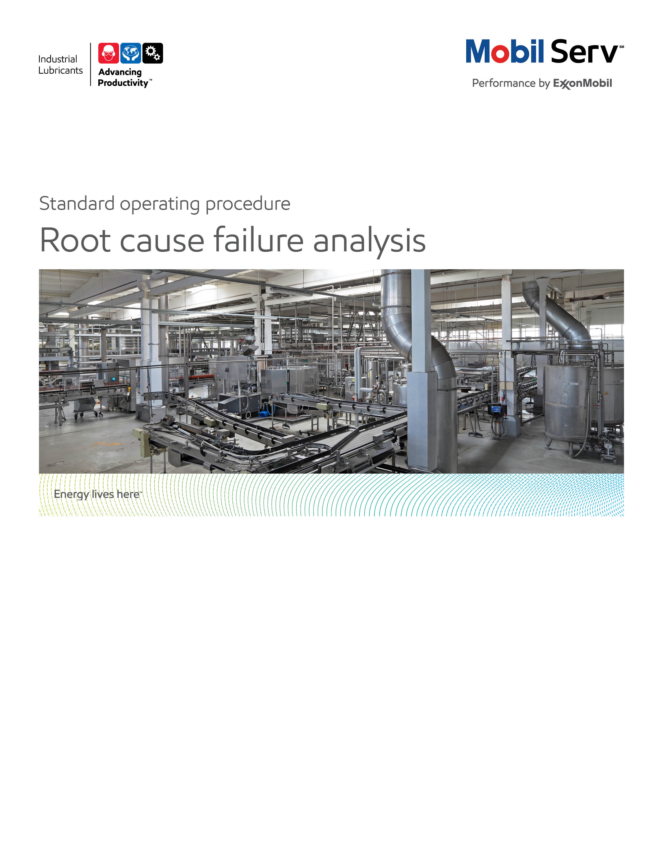

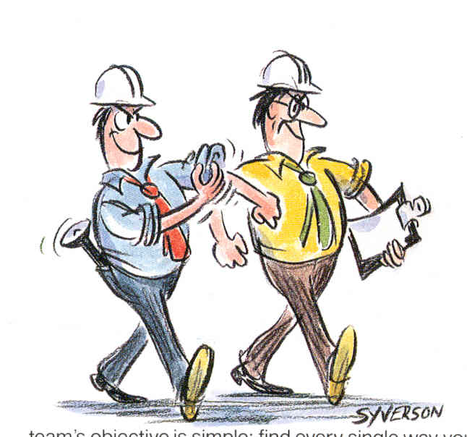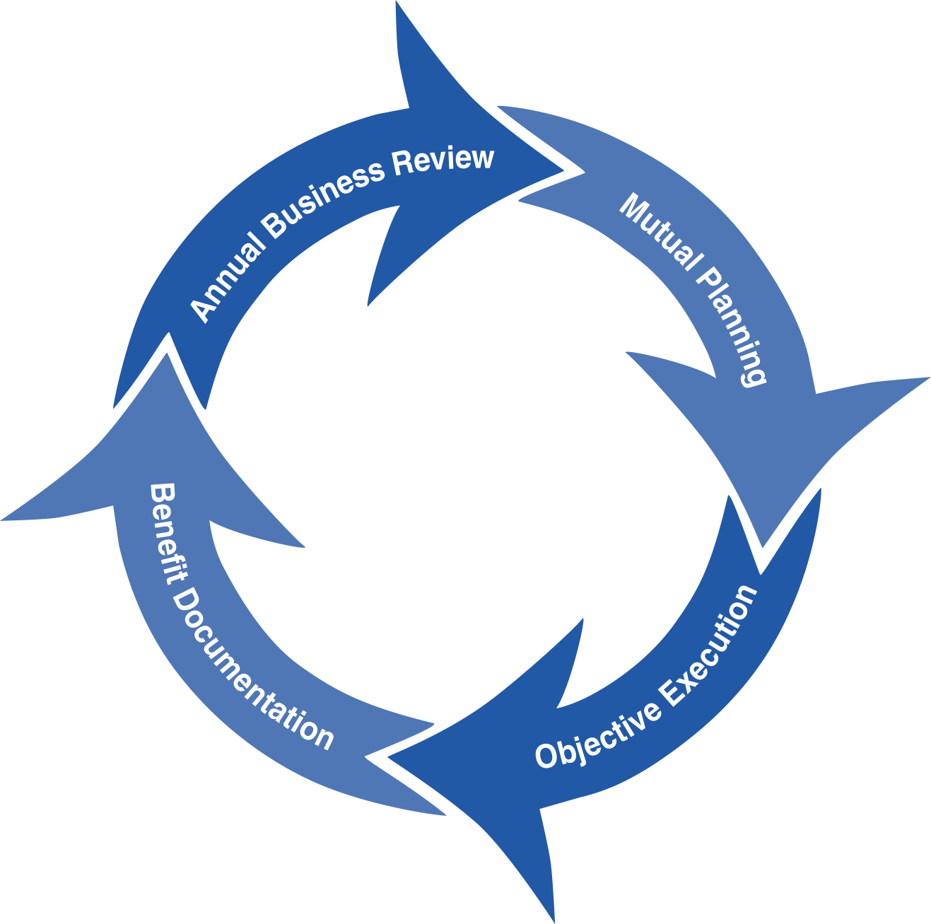
Standard Operating Procedure (SOP)
Read all of the steps in this SOP before beginning work. Follow customer labor requirements (eg respect Union work)

SOP: RCFA “Root Cause Failure Analysis” |  | DATE  12/13/2011 |  NEW  o REVISED  ___ Number |  | PAGE 1 of 3
TYPICAL CUSTOMERS  PES, Major Accounts, PI Investigations | WORK TYPE  Investigative | WORK ACTIVITY (Description)  Facilitate the investigative process to determine the “root cause” of equipment failure, PI Product Integrity issues and general problem solving.
DEVELOPMENT TEAM | POSITION / TITLE | REVIEWED BY/DATE |  | POSITION / TITLE
Rick Russo | Sr. Lube Engineer | John Sewall / 5/30/2012 |  | FES Advisor
Andy Lyczak | Sr. Lube Engineer | Tom Schiff / 9/27/2013 |  | FES Manager
PLEASE UTLIZE ATTCHED GENERAL JSA AS GUIDANCE AND, IF YOU HAVE DONE A SITE SPECIFIC JSA.
PLEASE ASSESS YOUR OWN CONDITIONS OR SPECIFIC SAFETY REQUIRMENTS AND BE SAFE.
http://intratta.na.xom.com/emdn/sbps/docs/safety/jsa/JSA_Conducting_Failed_Part_Root_Cause_Analysis.xls
http://intratta.na.xom.com/emdn/sbps/docs/safety/jsa/JSA_Wet_End_or_Dryer_Bearing_Inspection_Paper_Mill.xls
EQUIPMENT INDEPENDENT OF JSA DESIRED DOCUMENTATION
 CLIPBOARD OR TABLET PC  CRESCENT WRENCH   IR GUN  SCREWDRIVER'S   FLASHLIGHT  ELEC. BLACK TAPE   SAMPLE THIEF, BOTTLES & LABELS   RAGS   CAMERA  CHECK WITH CUSTOMER : OK TO USE OWN TOOLS OR MUST BE CUSTOMERS |  |  DAY OF - ENGINEERING SERVICE NOTICE (ESN) AS LEAVE BEHIND   FINAL - ENGINEERING SERVICE REPORT (ESR) WITH TOTAL COST of OWNERSHIP (TCO) SAVINGS (Digital Photos Required)  OTHER (SPECIFY)   IPP Plot (Incident Process Plot) Appendix/Back-up   PRIOR INSPECTION CHECKLISTS TO REVIEW TEMP PLOTS & CONDITIONS   Equipment Historical Records (if applicable)
TIME ESTIMATED TO COMPLETE THIS TASK NUMBER OF PEOPLE TO PERFORM THIS TASK
Equipment Failure Analysis |  | 2-3 hrs (onsite time)
FREQUENCY TO PERFORM THIS TASK SKLLS REQUIREED TO PERFORM THIS TASK
Situation specific (This task is driven by customer request)  Also from PES Process |  |  MECHANICAL APPTITUDE   SPECIFIC EQUIPMENT APPLICATION/OPERATION  KNOWLEDGE   EXCELLENT LISTENING SKILLS   RCFA QUESTIONING SKILLS   TRANSFERING LTS REPORTS INTO CUSTOMER REPORTS
JOB COMPETANCIES REQUIRED TO PERFORM THIS TASK, |  | TRAINING REQUIRED TO PERFORM THIS TASK
- Product Knowledge  - Equipment Application Knowledge  - Investigative Analysis Techniques  - Interpersonal Skills  - Utilizing LTS Lab Services |  |  RCFA COURSE IPP (EXXONMOBIL)   EQUIPMENT SPECIFIC FAILURE ANALYSIS COURSES (SKF  BEARING FAILURE eLearn W204   Incident Process Training   On The Job Training Shadowing Experienced LE   Tap Root/Kempner Tregoe   LTS Website http://ishareteam2.na.xom.com/sites/LSSG031/TechResources/Tech%20Resources%20Docs/Use%20LTS%20Lab%20Services.aspx

PURPOSE – To methodically lead and execute a RCFA “root cause failure analysis” to uncover the actual cause of equipment failure using a defined process, facts data and logic. If the proper “root cause” is identified the goal is to prevent a reoccurrence of the failure and to develop the proper corrective action steps. RCFA: the typical path for traditional root cause discovery and analysis begins with the discovery of a problem and ends with recommendations to solve the problem. A variety of techniques, both informal and structured, that can be used to determine these causes. This should complement reactive or proactive PES opportunities.

External Offer Sheet:
http://ishareteam2.na.xom.com/sites/LSSG031/TechResources/Tech%20Resources%20Docs/In-Depth%20Root-Cause%20Failure%20Analysis%20Sheet.pdf

(Internal Offer Sheet: Place holder when available)

LOCATION | JOB STEPS
Home office (Pre-Planning) | - Identify the problem to be solved  - Write a goal statement. What are we trying to accomplish?  - Determine members of the RCFA Team.  - Develop a communication plan both internal and external.  - Communicate with the customer on availability and timeline for a site visit to interview key personnel and physically look at the suspect equipment.
Customer site/where equipment is located | Step 1: Collect Base line Information (records and onsite physical inspection)  - Identify Unit(s) or components for inspection.  - Determine operating sequence of component. Review Tech Manual “operations and maintenance” sections to understand machine operations and maint requirements.  - Record operating conditions, environment.  - Develop IPP (Incident Process Plot) with customer to develop map and timeline of events.  - Record hours on equipment, components, and lubricant.  - Schematic of equipment, access to operation maintenance manual.  - Review current maintenance practices included oil analysis results, oil drain interval data, filtration information (with possibility of gathering deposits) and equipment rebuild history, replacement parts OEM or non-OEM or remanufactured parts, installation techniques, equipment storage, etc.  - Determine to whom results are reported what level of responsibility to take action.  - When possible determine TCO components that apply.  - Frequency of incidents.
Step 2: Assemble Toolkit

- Ensure camera is in working order. Second battery.
- Determine if power source is needed or available.
- Refer to JSA for all Safety items/PPE.
- Clipboard or other appropriate documentation gathering systems.
- Flashlight and batteries.
Step 3: Planning the Study
- Discuss and gain approval from station personnel all equipment and any hot work permits that will necessary to conduct the inspection.
- Schedule the event, and review any necessary safety precautions JSA’s (i.e. lock out tag out for gas, electrical, steam, water, etc.)
- Determine the availability of power. Not all sites have electricity. Have customer provide power sources for any equipment necessary for dis-assembly or re-assembly of machines.
- Arrange for mechanic to assist.
- Review any previous inspection data.
Step 4: Conducting the Study
- Ensure unit has been down and cooled.
- Ensure unit is ready to be inspected.
- Disassemble all parts for inspection.
- Gather any additional deposits, oil or parts for further lab analysis.
- Understand process, environment, operating conditions.
- Note equipment and component. Operating temperatures, lubricant in use, etc.
- Take photographs in sequence. Orient part so load zones can be identified.
- For engines, label components by cylinder number. For industrial applications, label multiple components by unique ID or orient them by direction.
- Start from one end and the process and look for deviations in operations and performance from records and interviews of mechanics and operators
- Ensure you contact customer immediately of any significant abnormal conditions identified.
- Remove lock out tag out lock and identifier.
- Review immediate findings with customer.
- For situations where product quality is questioned, obtain C of A and secure shipment retains for LTS analysis. Gather batch numbers for checking manufacturing up line. Obtain retain samples from deliveries. Ensure to follow proper sampling procedures. Ensure to follow instructions for proper use of LTS (including sample labeling for potential sample hazards that might be posed to the LTS lab – e.g. ammonia from a refrigeration unit). LTS Portal Link
- Use OEM and other equipment/component failure guides to assist with abnormal condition (wear, deposits, etc.) observed.
- Using the Casual Factor Analysis tool take the direct causes identified in the IPP and ask “why” they took place three to five times until you have reached a conclusion that uncovers the root causes.
- Ensure you have good data (pictures, reference wear patterns that correlate to observed customer equipment, used oil analysis/other LTS data, etc.) to support the direct causes, casual factors, and root causes.
- Based on the root causes identified, create a corrective action plan that generates a positive TCO (must identify the savings and costs for each recommendation made) for the customer with specific next steps/responsibilities for each action item.
Step 5: Post Study
- Review immediate findings with customer document in a brief written or typed ESN Engineering Service Notice.
- Review finding with team members.
- Determine cause and effect and identify actual “Root Cause”.
- Check against known resources, OEM, EB internet resources.
- Develop test solutions.
- Offer steps to implement solutions to monitor performance.
- Write formal final RCFA Engineering Service Report for presentation to customer.
- Verify to whom results are reported.
Feedback about this SOP - Send to Field Engineering Advisor/Supervisor

DOCUMENTING YOUR WORK –

Documentation: The inspection results should be documented in an Engineering Service Notice or Engineering Service Report. TCO calculations that may apply are:

- Revenue Enhancement: To determine the dollar impact a value-added event has on a customer’s revenues.
- Asset Improvement: To evaluate the reduction in a customer’s asset base and the resulting reduction in possession costs for no longer being required to maintain that asset.
- Process Improvement: To determine the reduction in the customer’s operating costs because of the reductions achieved in personnel requirements to perform specific tasks.
- Expenditure Reduction: To help document the actions taken that have helped to reduce the customer’s total annual spend.
- Special Services: To determine the value you added to your customer for the services you provide above and beyond the normal service requirements.

Documentation Links:

- Examples ESRs
http://ishareteam2.na.xom.com/sites/LSSG031/TechResources/Tech%20Resources%20Docs/Mining_and_Construction_Engineering_Recommendation_Failure_Analysis.pdf
http://ishareteam2.na.xom.com/sites/LSSG031/TechResources/Tech%20Resources%20Docs/Mining_and_Construction_Engineering_Recommendation_Failure_Analysis_No_2.pdf
http://ishareteam2.na.xom.com/sites/LSSG031/TechResources/Tech%20Resources%20Docs/Paper_and_Forest_Products_Engineering_Recommendation_U_Joints.pdf
http://ishareteam2.na.xom.com/sites/LSSG031/TechResources/Tech%20Resources%20Docs/Power_Generation_Engineering_Recommendation_Failure_Analysis.pdf
- Product Integrity Checklist

http://ishareteam2.na.xom.com/sites/LSSG031/TechResources/Tech%20Resources%20Docs/Product%20Integrity%20Incident%20Response%20Checklist.docx

- IPP/Causal Factor Materials

