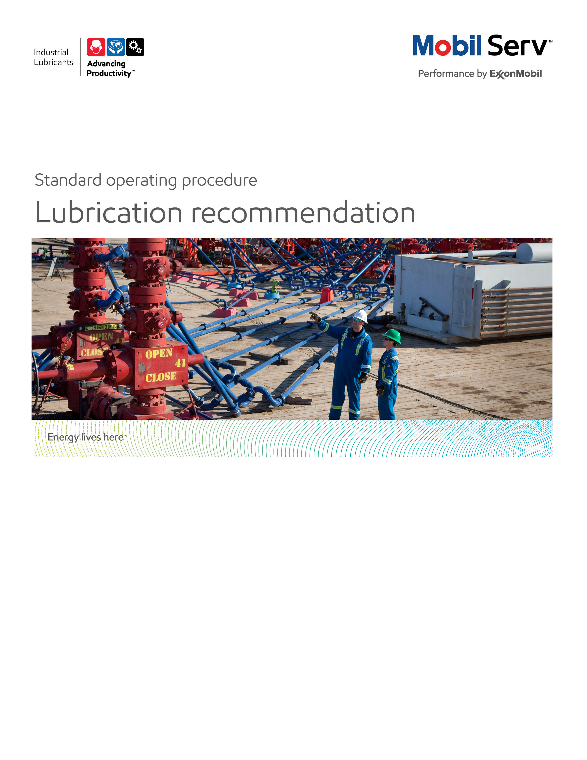
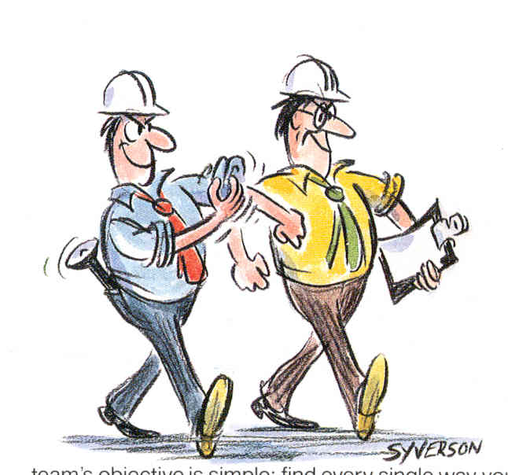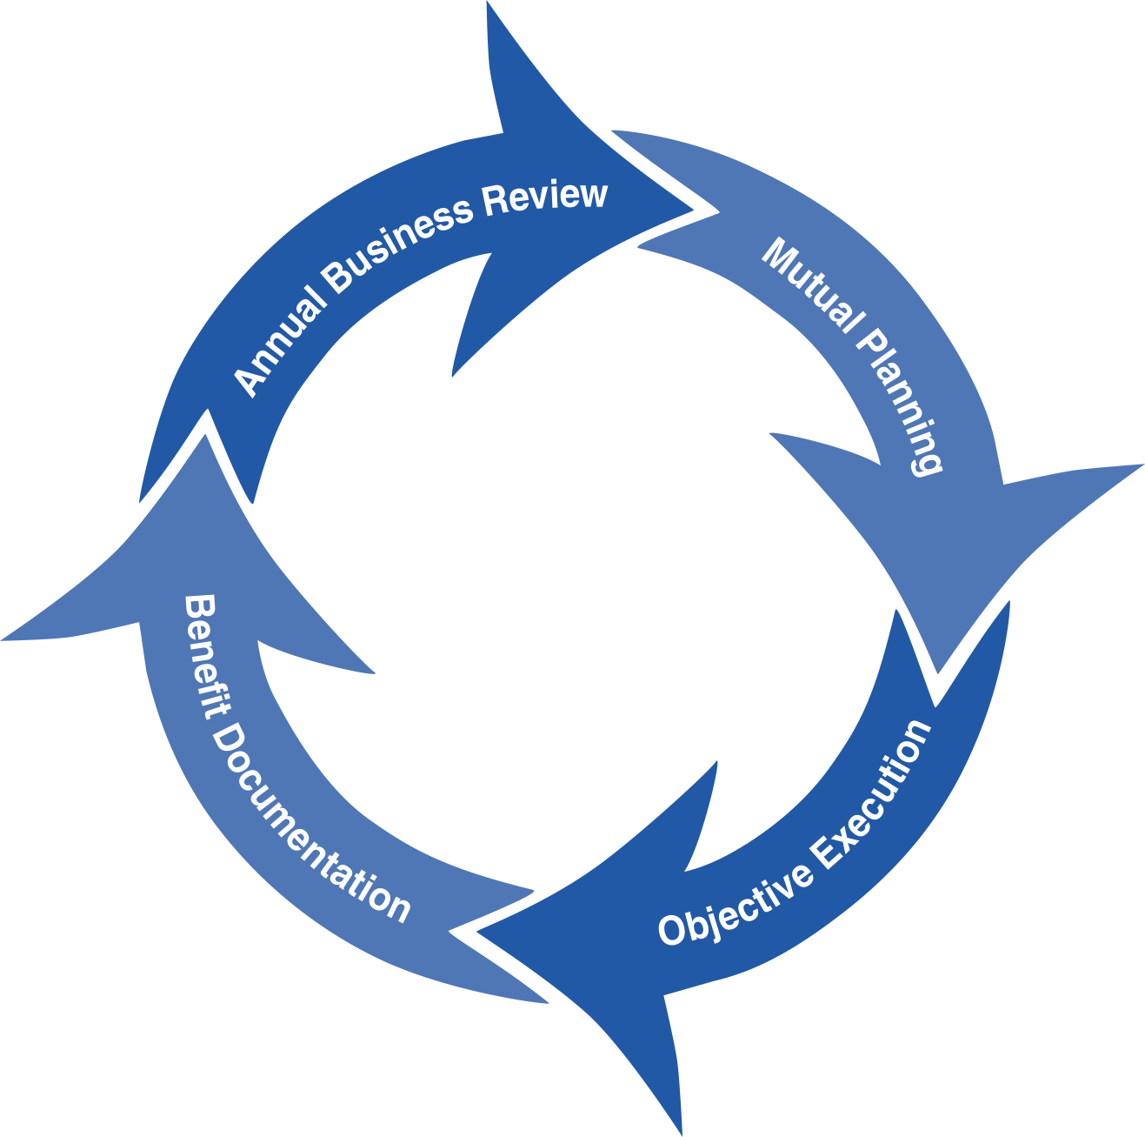
Standard Operating Procedure (SOP)
Read all of the steps in this SOP before beginning work. Follow customer labor requirements (eg respect Union work)

SOP: Basic Lubricant Recommendation |  | DATE  5/13/2015 |  NEW  o REVISED  ___ Number |  | PAGE 1 of 4
TYPICAL CUSTOMERS  Various: PAPER, PLASTICS, GEN MFG, ENERGY OFF HIGWAY,ETC. | WORK TYPE  Lubricant Recommendation | WORK ACTIVITY (Description)  Steps to make basic lubricant recommendations for end use customers
DEVELOPMENT TEAM | POSITION / TITLE | REVIEWED BY/DATE |  | POSITION / TITLE
Tom Schiff | Global FES Manager | Tom Schiff 22May2015 |  | Global FES Manager
Gilles Delafargue  20 May 2015 | Global FES Advisor
PLEASE UTLIZE ATTCHED GENERAL JSA AS GUIDANCE AND, IF YOU HAVE DONE A SITE SPECIFIC JSA.
PLEASE ASSESS YOUR OWN CONDITIONS OR SPECIFIC SAFETY REQUIRMENTS AND BE SAFE. JSA Lube Survey General Plant
EQUIPMENT/TOOLS INDEPENDENT OF JSA DESIRED DOCUMENTATION
 LAPTOP/IPAD   LUBRICANT CALCULATORS (EHL, GREASE, ETC)   EMEBS   LOOBLE   OEM/EQUIPMENT BUILDER LITUATURE   PRODUCT DATA SHEETS   TECHNICAL HELP DESK   LUBES GBU TECHNICAL RESOURCE LIBRARY (LINK)   GLOBAL FES TOOLBOX |  | REACTIVE NON PES/MAJOR ACCOUNT OR ROUTINE RECOMMENDATION FOR A PES/MAJOR ACCOUNT   E-MAIL OR PHONE CALL CAN BE SATISFACTORY  PES/MAJOR ACCOUNT WITH RECOMMENDATION THAT HAS POTENTIAL TO SOLVE SUFFERING POINT/DELIVER VALUE   DAY OF - ENGINEERING SERVICE NOTICE (ESN) AS LEAVE BEHIND FOR ANY IMMEDIATE FOLLOW UP ITEMS IDENTIFIED DURING THE TRAINING SESSIONS   FINAL - ENGINEERING SERVICE REPORT (ESR) OR ENGINEERING SERVICE LETTER (ESL) WITH TOTAL COST of OWNERSHIP (TCO) SAVINGS. MAY INCLUDE LUBRICATION CHART  OTHER (SPECIFY)
TIME ESTIMATED TO COMPLETE THIS TASK NUMBER OF PEOPLE TO PERFORM THIS TASK
DEPENDS ON THE NUMBER OF RECOMMENDATIONS REQUESTED. TYPICALLY ONE RECOMMENDATION CAN RANGE FROM FIVE TO 60 MINUTES. SOME RECOMMENDATIONS MAY REQUIRE CONSULTATION WITH EB ENGINEER, BUILDER, OTHER RESOURCES OR PERFORM CALCULATIONS WHICH CAN TAKE LONGER |  | 1 CAPABLE EM OR DISTRIBUTOR PERSON  TYPICALLY THE CAPABLE PERSON (SALES ADVISOR, THD ENGINEER, LUBRICATION ENGINEER, DISTRIBUTOR SALES REPRESENTATIVE, OR DISTRIBUTOR LUBRICATION ENGINEER) RECEIVING THE REQUEST MAKES THE RECOMMENDATION. THEY MAY ESCALATE TO OTHERS OR THD (TECHNICAL HELP DESK) AS NEEDED IF THEY NEED ASSISTANCE How to Obtain Technical Support
FREQUENCY TO PERFORM THIS TASK COMPETENCIES/SKLLS REQUIREED TO PERFORM THIS TASK
VARIES BASED ON CUSTOMER NEEDS; TYPICALLY REACTIVE (CUSTOMER REQUEST, DISTRIBUTOR INQUIRY, ETC.) BUT CAN BE AN OBJECTIVE FOR A PES CUSTOMERS TO HELP THEM ACHIEVED IDENTIFIED BUSINESS GOALS AND/OR PROVIDE SOLUTIONS TO A SUFFERING POINT |  |  CUSTOMER EQUIPMENT / APPLICATION UNDERSTANDING AND ASSOCIATED LUBRICANTS AND LUBE APPLICATION   KNOWLEDGE FOR THOSE APPLICATIONS POINTS
 |  | TRAINING REQUIRED TO PERFORM THIS TASK
 PRODUCT KNOWLEDGE AND RECOMMENDATIONS
 EQUIPMENT APPLICATION (INCLUDING LUBE APPLICATION)
 TROUBLE SHOOTING PROBLEMS/FAILURE ANALYSIS
 EQUIPMENT INSPECTIONS
 ENGINEERING REPORT WRITING/TCO
OTHER RESOURCES REQUIRED OR SUPPORT
TECHNICAL LINKS
 Lubes GBU Tech Resource Library Link

PURPOSE - This document provides guidance for capable ExxonMobil and Distributor persons to help ensure that product recommendations provided to customers meet the customer needs as well as Brand and Product Integrity Management standards under all reasonable circumstances.

External Offer Sheet: TBD

Internal Offer Sheet: TBD

LOCATION | JOB STEPS
Key Terms | - A Product Recommendation is an offer of suitability for use of an EM lubricant provided by a capable ExxonMobil or Distributor person for a client’s specific application, referencing OEM, EB requirements and/or product approvals/recommendations  - Fit to Application Evaluation is a review and an assessment of all relevant information provided by the client and collected from appropriate Information Sources about a lubricant application including OEM, EB’s specifications and industry standards and the client’s application operating conditions.  - Information Source is a reference used to support an appropriate product recommendation for a client’s specific application. Technical databases, EB or OEM Documentation/ eMEBS, , technical response internal tools, expert knowledge and systems supporting technical services are the main sources of information used for product recommendations. Three categories of Information Sources are defined:  - EM Standard Information can be gained from a standard system or a database or a tool approved by ExxonMobil for internal and/or external use as a technical information source or as a direct product recommendation source. EM Standard Information shall be used as a primary information source (example: eMEBS, Refrigeration Product Selector…).  - Supportive Information can be gained from appropriate sources (see Equipment/Tools Section) for product recommendation guidance. Supportive Information should be subject to capable person evaluation. Prudent measures must be taken to ensure information is truthful, accurate and definitive. If questionable, it shall not be used. (Example : POP or Benefit reports showing similar case, industry claims)  - Other References can be gained from other than above stated sources. The reference information shall be used only as a complementary source of information. Prudent measures must be taken to ensure information is truthful, accurate and definitive. If questionable, it shall not be used. (Example: Technical papers from symposium documenting similar case)
Request/Need for lubricant recommendation for a specific application | The following principles must be followed by the capable person when recommending a product.  Principle 1  Product Recommendation shall be based upon a Fit to Application Evaluation.  Principle 2  Product Recommendation shall be based upon EM product specifications and claims supported by product documentation.  Principle 3  Appropriate trustable Information Sources shall be used for Product Recommendation to support proper EM product representation and meet the customer needs.(especially be extremely careful with pieces of information extracted from INTERNET, potentially uncontrolled)  Product Recommendation must adhere to the above Product Recommendation Principles and shall be based on appropriate information from Information Sources. Especially avoid “read-across” from competitive products, which might have been wrongly selected.  The capable persons making the recommendation is responsible for collection of all relevant information which is necessary for providing an appropriate Product Recommendation for client’s application, assuring proper product representation and customer satisfaction.  The capable person making the recommendation needs to recognize that information from appropriate sources, may change and should take prudent measures to ensure that he/she is using the most up-to-date information based on known changes occurring to the product line or other changes that may affect the accuracy of information being used. Especially ensure that the last up to date EB or OEM information is consulted.  If the information being referenced is suspect or questionable, the capable person making the recommendation shall not use the information for advice to customers/requestors and should contact a document owner or an appropriate expert for confirmation.  How to Obtain Technical Support  When the request/need for recommendation of an alternative lubricant to a competitor product or an obsolete EM product, avoid using just a straight cross reference table/tool for the recommendation. The capable person making the recommendation should try to best understand the application and operating conditions (e.g. temperatures, environmental contaminates, safety considerations, compatibility issues, etc.) when making the recommendations. . Especially any suffering point should be identified via discussion with customer and/or through site inspection. This is a key point to propose advanced lubricants or “problem solvers”, like synthetic lubricants.  For significant recommendations or those justified for PES/Major accounts, the best practice includes surveying the customer’s equipment and collecting relevant data, or suffering points , to assist in making and document the recommendation and its benefits.  For PES/Major Account product recommendation requests/opportunities, understand the “as is” equipment performance/reliability/cost impacts, and suffering points, prior to making the recommendation. Understand the customer’s business goals and ensure to make recommendations to improve the customer’s productivity and reduce their total cost of ownership. Use this information to document the potential benefits of the recommendation or the achieved value received after the customer adopted the recommendation.
ESR/ESL to customer | For significant recommendations or those justified for PES/Major accounts, the best practice includes writing an Engineering Service Notice (ESN) after you leave customer site to review preliminary summary of the product recommendation and recommended follow up activity. Then follow up with an ESR or ESL with documented TCO value (recommendation justification).
Follow up | For PES/Major accounts, best practice (for recommendations with potential significant customer value) is to follow up on the recommendation to confirm/document the achieved value for the customer. In addition, the follow up visit can look for expansion of the recommendation to other areas of a customer facilities or to other facilities in their company. These recommendations/benefits should be prepared in an Engineering Service/Benefit Report.
Feedback about this SOP - Send to Chief Engineer
DOCUMENTING YOUR WORK – Product recommendations (typically for Major/PES accounts and not for routine recommendations) can be a significant way to assist customer reach their equipment reliability goals by addressing potential or actual suffering points. Persons making product recommendations should document the recommendation (technical rationale), case for action, follow up recommendations and their value using Mobil Serv Report Writer (3D) and TCO approach.

TCO is a process to quantify improved profit through the implementation of an effective lubrication program. In order to document savings involved in a partnership between the customer and Mobil Industrial Lubricants, the following categories of value-added savings will be reviewed: Revenues, Assets, Processes, and Expenditures

The TCO Worksheets are the preferred format to include in your report. Proper placement is an Appendix. Additional guidance will incorporate our messaging of TCO to include Sustainability, Safety and Productivity relationships. Quantify these costs on an annual basis. We should use customer cost/impact data. If the customer does not know the numbers then utilize estimates from experience or other resources (repair shops, OEMs, etc.) then have the customer agree to the numbers/impacts. Both realized benefits and cost avoidance should be considered.

Expenditure Reduction - reduced equipment and/or lubricant purchase costs are the most typical expenditure savings. These may result from the offset of extending lube application intervals from the previous lubricant or greases against the increased price of Mobil products flagships and premium or other recommendations to modify the lubricated equipment, lubricant delivery, lubricant purification systems, etc.)

Process Improvement - the hourly wages (including burden) for personnel to perform existing tasks e.g. replaces the lubricant, or repair equipment reduced in part by the product recommendation, are typical Process improvement savings. If equipment replacements or lubricant change outs are reduced, use these to determine Process improvements. If lubricant usage is reduced, use the time to handle drums and the time to dispose of used lube to determine Process improvements.

Revenue Enhancement - any equipment failure, anticipated timely via Used Oil Analysis follow up for example, may be repaired during normal maintenance and so reduce the potential for downtime. “Unscheduled Downtime”, results in lost production and most often, scrapped parts or material. This may allow the customer to plan for a replacement during a planned outage instead of an emergency shutdown. Savings due to production losses avoided may be significant.

Asset Improvement - use the customers "cost to carry" inventories. This is used from the Expenditures components for example, if you reduce the quantity of lubricant needed, take that amount cost and multiply by the "cost to carry" to determine the Asset value.

Safety Improvement – this is typically man-hours of avoided equipment interface exposure by increasing time between lubricant application/changes, reduced equipment repairs, etc. This could also include incidents caused by slips but do not document improvements in actual number of accidents or incident rates but rather the potential to impact those statistics.

Environmental Improvement – this is typically quantified by reduced lubricant volume disposed or reduced CO2 emissions

Refer to Expenditure Reduction, Process Improvement, Revenue Enhancement, and Asset Improvement to develop TCO. The Total Cost of Ownership (TCO) Database has many equipment typical costs in it, or consults with the OEM or equipment distributor to finalize your TCO. In all cases, ensure your customer agrees with the cost estimates. Sometimes you may need to suggest an estimated cost and get the customer to agree/negotiate to acceptable figures.

TCO Database

Include any “negative” components of TCO from your recommendations (which should be rather considered as an “investment”);extra cost of lubricant first fill (synthetic Vs mineral), new lube systems, filtration, water removal, enhanced predictive monitoring, increased labor (to do the job correctly the first time), new equipment; e.g. to replace under sized equipment.

Model Reports
Product Recommendation Example
Product Recommendation using EHL Example
Product Recommendation using EHL Example #2

