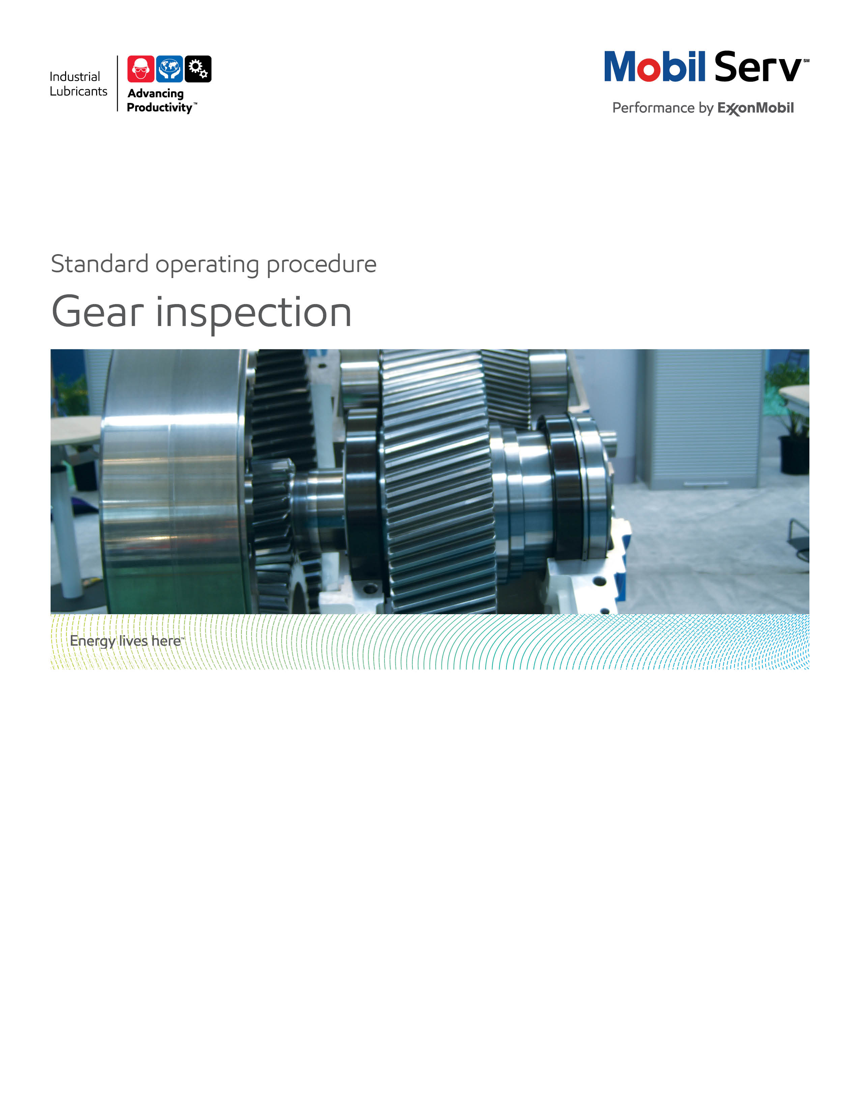
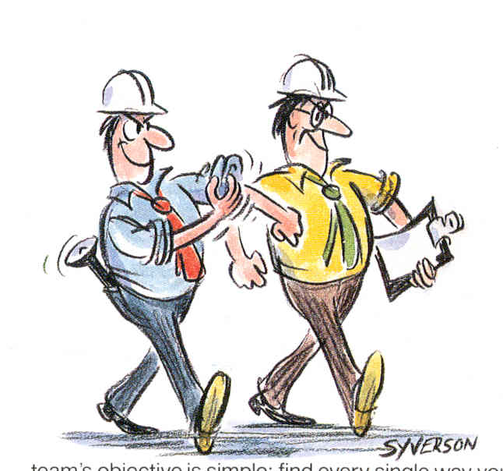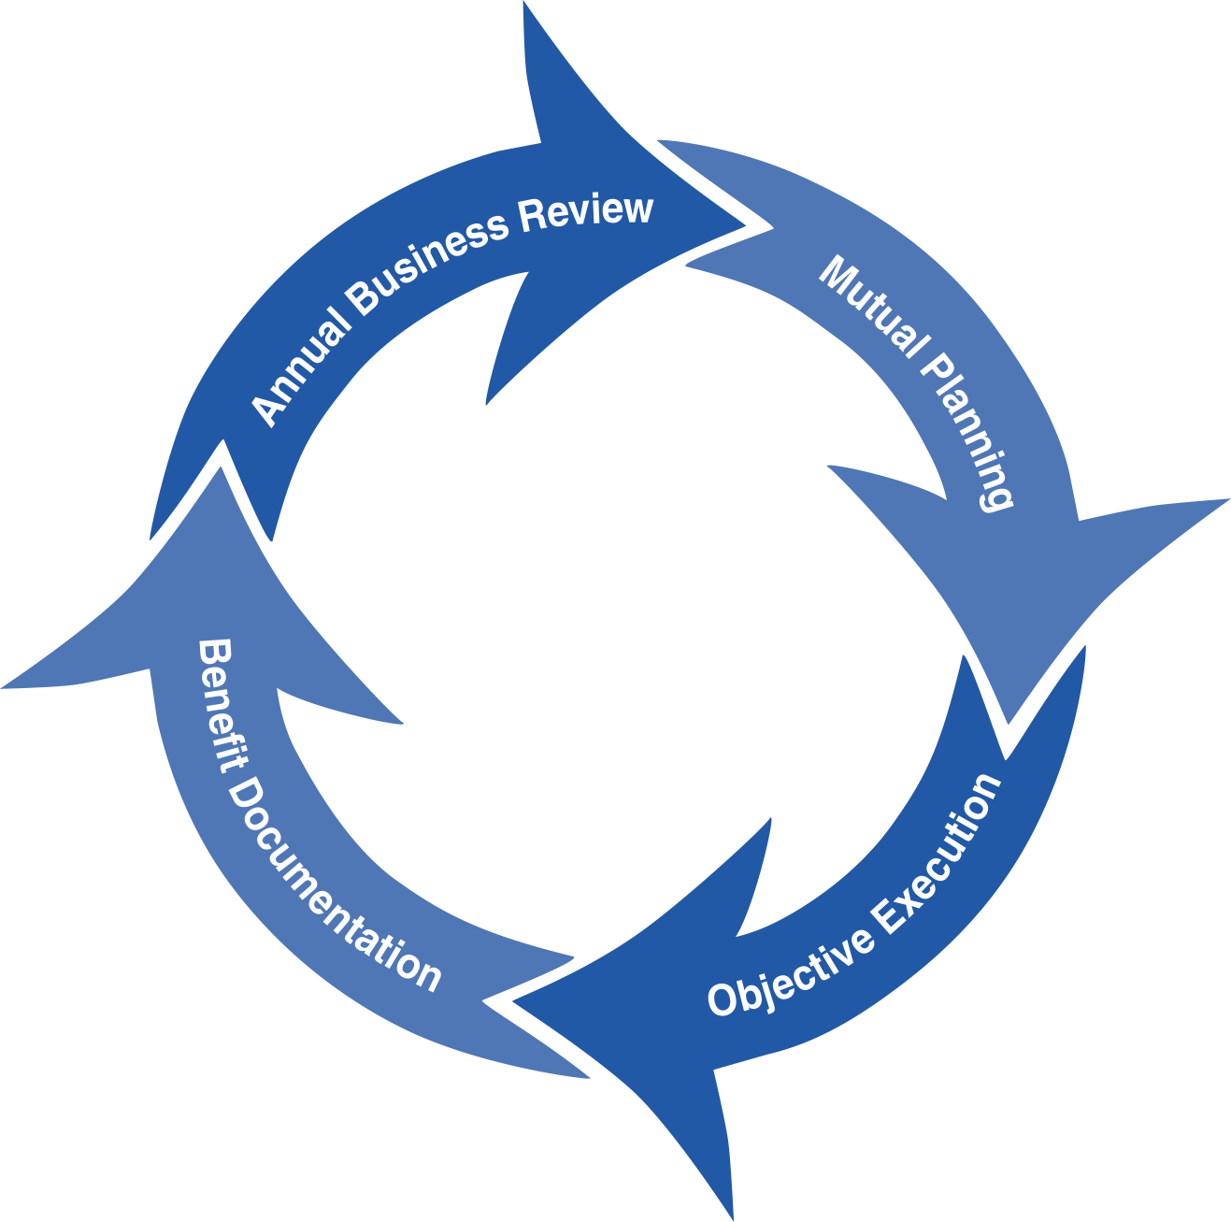
Standard Operating Procedure (SOP)
Read all of the steps in this SOP before beginning work. Follow customer labor requirements (eg respect Union work)

SOP: Enclosed Gears Inspection, Stationary Equipment |  | DATE  5/09/2011 |  NEW  o REVISED  ___ Number |  | PAGE 1 of 5
TYPICAL CUSTOMERS  Gen Mfg, Cement, Steel, Paper mills | WORK TYPE  Enclosed Gears Inspection | WORK ACTIVITY (Description)  Oil Sampling, Temperature Checks, Filter and Breather Inspections, Teeth wear mode
DEVELOPMENT TEAM | POSITION / TITLE | REVIEWED BY/DATE |  | POSITION / TITLE
Fabian Geniz | Lube Engineer | Luis Rojas 10/03/2011 |  | FES Supervisor
Ricardo Orta | Lube Engineer | Tom Schiff 10/24/2012 |  | FEM Americas
PLEASE UTLIZE ATTACHED GENERAL JSA AS GUIDANCE AND, IF YOU HAVE DONE A SITE SPECIFIC JSA.
PLEASE ASSESS YOUR OWN CONDITIONS OR SPECIFIC SAFETY REQUIRMENTS AND BE SAFE.
Paper Mill Gear Inspection JSA
Cooling Tower Gear Inspection JSA
Wind Turbine Gear Inspection JSA
General Gear Drive Inspection JSA
EQUIPMENT INDEPENDENT OF JSA DESIRED DOCUMENTATION
 CLIPBOARD OR TABLET PC  BORESCOPE   IR GUN  RAGS   FLASHLIGHT  TELESCOPIC MAGNET   SAMPLE KIT  SIGNUM ONBOARD  TEST KITS   CAMERA   GEAR INSPECTION REPORT TEMPLATE  DO NOT OPEN THE GEAR CASE BY YOURSELF. ALLOW CUSTOMER REPRESENTATIVE / AUTHORIZED PERSONNEL TO OPEN IT. |  |  DAY OF - ENGINEERING SERVICE NOTICE (ESN) AS LEAVE BEHIND   FINAL - ENGINEERING SERVICE REPORT (ESR) WITH TOTAL COST of OWNERSHIP (TCO) SAVINGS  OTHER (SPECIFY)   GEARBOX INSPECTION CHECKLIST   PRIOR INSPECTION CHECKLISTS TO REVIEW TEMP PLOTS & CONDITIONS
TIME ESTIMATED TO COMPLETE THIS TASK NUMBER OF PEOPLE TO PERFORM THIS TASK
30 - 40 MINUTES PER ENCLOSED GEAR UNIT (ONCE OPEN) |  | 1 -2
FREQUENCY TO PERFORM THIS TASK SKLLS REQUIREED TO PERFORM THIS TASK
DEPENDS ON GEAR SET CONDITION, USUALLY ONE TIME PER YEAR FOR UNIT. IN CASE THAT GEARS PRESENT SOME DAMAGE, SHORTER FREQUENCY SHOULD BE AGREED WITH CUSTOMER. |  |  GEAR FAILURE MODE ANALYSIS   GEARS LUBRICATION (LUBRICATION FUNDAMENTALS, 2ND EDTION, PIRRO & WESSOL, CHAP 8, PAGES 204-221)
JOB COMPETANCIES REQUIRED TO PERFORM THIS TASK, |  | TRAINING REQUIRED TO PERFORM THIS TASK
PRODUCT SELECTION & APPLICATION - GEAR OILS.  TECHNICAL KNOWLEDGE  PROBLEM SOLVING  INDUSTRIES - GENERAL MANUFACTURING, STEEL MILLS, METALS  - SUCCESFULLY PERFORMED GEAR INSPECTIONS |  |  lms - TECHNICAL WRITTING eLearn   lms - GEARS, BEARINGS & COUPLINGS eLearn   lms - PROBLEM SOLVING - ANALYTICAL eLearn   INDUSTRIAL GEAR LUBRICATION ANSI/AGMA 9005-E02 STANDARD   TCO & BENEFIT SELLING   VIDEO - MOBILGEAR 600 XP SERIES   On The Job Training Shadowing Experienced LE

PURPOSE - To describe the process of conducting an enclosed gear box inspection, with the desired reporting that provides the value back to the customer that supports our standard Marketing Offer.

(External Offer Sheet:
http://intratta.na.xom.com/emdn/sbps/technical/engg_services/Americas/Gear_Inspection%20.pdf

(Internal Offer Sheet: Place holder when available)

LOCATION | JOB STEPS
Planning for the gear inspection from home office  Production Area for Equipment to be Inspected | - Before visiting the gearbox site, set plans/expectations with responsible customer personnel for; site safety (follow JSA), specific gearboxes to inspect, personnel to ensure LOTO, personnel for opening/closing inspection covers, accessing gearboxes, other work planned near gearboxes/potential risks; welding, load lifting, forklift traffic, crane operation, etc.  - Review used oil analysis data or abnormal vibration data from customer.  - Verify that the gearbox drawings, disassembly tools and adequate inspection facilities are available.  - Ask for as much background information as possible, including manufacturer’s part numbers, gear and bearing runtime (hours), service history and lubricant type.  - Assemble your inspection equipment, including items such as a flashlight, magnifying glass, measuring tools, felt tip markers, lubricant sampling equipment, photographic equipment and documentation worksheets.  - Review inspection process and verify gearbox opening/closing needs with the technician who will be working with you.  - Review the gearbox assembly drawings with the technician, checking for potential disassembly problems.
Enclosed Gear Inspection | In case the equipment is operating, thoroughly inspect its exterior. Use the Gearbox checklist as a guide to ensure that you record important data that would otherwise be lost once disassembly begins:  - Leakage at shaft or any fitting  - Oil level  - Oil flow meters and pressure gages to see if working properly  - Oil pump, meters and lines for proper operation and any leakage  - Heat exchanger condition and temperature differentials (oil and water)  - Check oil filter indicators or differential pressures gages if working properly  - Bulk oil and bearings temperature  - Breather condition  - Abnormal noise or vibration  - Sampling points  - Seals and keyways  If the gearbox is stopped after your arrival, allow the equipment to cool.  Perform LOTO, make sure electrical energy to the motor and oil supply pumps is locked out and tagged out.
Once the gearbox is stopped and cooled:
- Have technician open inspection cover. If opening inspection covers is not possible, use the borescope and access gears through bolt holes and breather pipes. Refer to Gas Engine Borescope SOP for borescope operating practices.
- Allow oil vapor to dissipate; avoid breathing it.
- If a schematic of gears is not available, draft it by hand to include if possible number of teeth, diameter, face width, center distance and bearings designation. Record data from the OEM plate on the gearbox and electric motor cases.
- Verify the lubrication method: splash or bath.
- Look at inspection cover or top of gearbox for signs of condensation.
- Look at oil galleys for any debris built up that could impede oil flow to bearings.
- Inspect closely the dynamic surfaces of gear teeth and bearings and record their condition. Define wear patterns at each section of gears inspected; addendum, dedendum, root, tip.
- Make pictures of gears, bearings and interior of gearbox, so you can refer them in your report
- Look at the bottom of the gearbox for contaminants / debris / foam.
- If gear teeth need cleaning for a proper photograph or further observation, have customer wipe them clean.
- Take pictures of gear teeth in a way that wear, pitting and marks on the surface can be seen.
- Try to take pictures in angle to avoid the flash light of the camera to be reflected on the teeth surface and captured in the image. Use flashlight to help camera focus than move flashlight off area to be photographed and take picture. Check saved image for proper exposure.
- Take as many pictures as needed
- If possible, take pictures of bearings and oil nozzles
- Concentrate on collecting evidence, not on determining the cause of wear. Regardless of how obvious the cause may appear, do not form conclusions until all the evidence is considered.
- Remove LOTO on Oil Pumps and ask customer to turn on oil pumps to observe oil flow through nozzles for proper delivery. Be aware of spray around the inspection cover.
- Once you have enough pictures, ask the customer to close the cover, remember that gearbox should be open the shortest time possible, to avoid contaminants getting inside.
- Obtain an oil sample if not part of routine sampling program.
- Double check for the number of rags you have at the end of inspection; make sure you haven't forgotten any items inside the gearbox.
- Collect all the equipment used in the inspection
Maintenance / Operation office | - Download the pictures to your laptop and name each one according to the gear it shows and a consecutive number.  - Review your observations with maintenance personnel, regarding wear, marks on teeth surface, contaminants and any other condition.  - Give recommendations on lubrication or maintenance practices that may apply  - Prepare an ESN with the most important findings and recommended action items of the condition of the gearbox and comments based on wear and observations.  - On the ESN describe components in a consistent way. For example, always start with the same part of a bearing and progress through the parts in the same sequence. This helps to avoid overlooking any evidence.
Home Office | - Prepare gear inspection using the ESR template; see inspection example next.
Feedback about this SOP – Send to Field Engineering Support Supervisor/Advisor

Equipment to perform the task (illustrative):

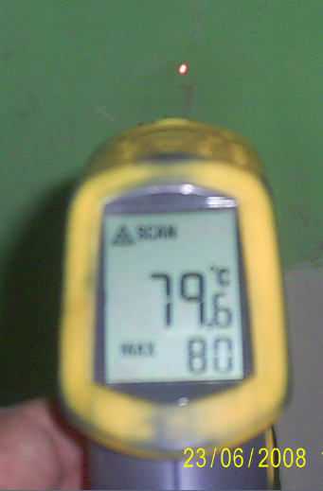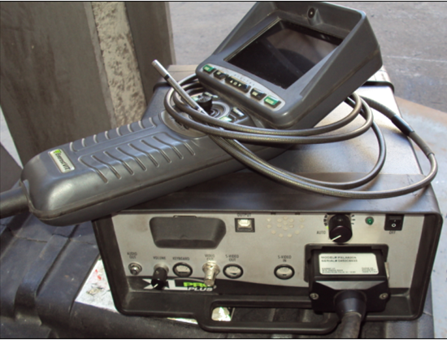
IR Gun Borescope

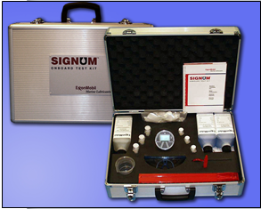
Signum Field Test Kit

DOCUMENTING YOUR WORK - The Gear Inspection is used to verify the performance of Mobil premium and flagship gear oils. The Gear Failure Inspection Instructions and Gear Failure Inspection Report can be used as a guide to assist in the inspection and preparing an Engineering Service Notice or Engineering Service Report. Proper placement is in an Appendix. TCO calculations that may apply are: Expenditures Reduction, Process Improvement, Revenue Enhancement and Asset Improvement as detailed below. The TCO Worksheets are the preferred format to include in your report. Proper placement is in an Appendix. Additional guidance will incorporate our messaging of TCO to include Sustainability, Safety and Productivity relationships.

Expenditure Reduction - reduced lubricant purchase costs are the most typical expenditure savings. These only result from the offset of extending lube application intervals from the previous lube against the increased price of Mobilgear 600 XP / Mobil SHC Gears / Mobil SHC 600's products. Expenditures could also be the cost of gears and bearings replacement (cost depends on size of each). This may allow the customer to plan for a replacement during a planned outage instead of an emergency shutdown. A third expenditure may come from disposal costs of used oil. Find out how much the unit cost of disposal is and use the consumption on an annual basis. Make sure to factor in the reduced usage with premium and flagship Mobil gear oils as they apply or have applied in time.

Process Improvement - the hourly wages (including burden) for personnel to perform existing tasks. If gears and bearings replacements or lubricant change outs are reduced, use these to determine Process improvements. If lubricant usage is reduced, use the time to handle drums and the time to dispose of used lube to determine Process improvements.

Revenue Enhancement - any serious abnormal gearbox or lubricant condition observed may be repaired during normal maintenance and reduce the potential for downtime. “Unscheduled Downtime”, resulting in lost production and most often, scrapped parts or material.

Asset Improvement - use the customers "cost to carry" (usually 20%) inventories. This is used from the Expenditures components, for example, if you reduce the quantity of lube needed, take that amount cost and multiply by the "cost to carry" to determine the Asset value.

Refer to Expenditure Reduction, Process Improvement, Revenue Enhancement, Asset Improvement and TCO Summary Worksheet.

Documentation Links:

How to inspect a Gearbox, Robert Errichello article, Machinery Lubrication, (2/2012)

Thunder Clinic – Gear Inspection Best Practices, (10/2012)

Execution: Team using proper tools and equipment

