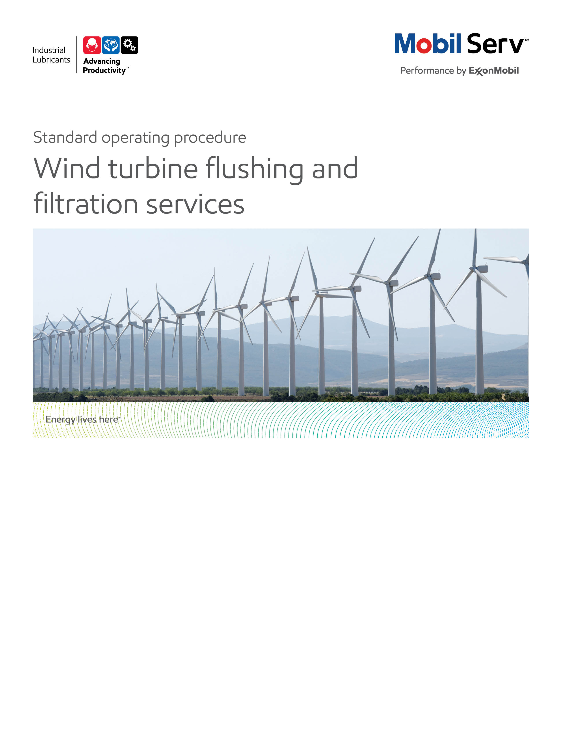


Standard Operating Procedure (SOP)
Read all of the steps in this SOP before beginning work. Follow customer labor requirements (eg respect Union work)

SOP: Wind Turbine Gear Inspection |  | DATE  3/15/2015 |  NEW  o REVISED  ___ Number |  | PAGE 1 of 3
TYPICAL CUSTOMERS  Wind Turbine Equipment Inspections | WORK TYPE  Gear Inspection | WORK ACTIVITY (Description)  Oil Sampling, Gear Inspection - borescope or normal static gear inspection
DEVELOPMENT TEAM | POSITION / TITLE | REVIEWED BY/DATE |  | POSITION / TITLE
Brad Pricket | Lube Engineer | Bill Fuller |  | AMR FES Manager
 |  | Tom Schiff 03/15/2015 |  | Global FES Manager
PLEASE UTLIZE ATTACHED JSA'S AS GUIDANCE (Wind Turbine Climbs and Gear Inspections) AND, IF YOU HAVE DONE A SITE SPECIFIC JSA. PLEASE ASSESS YOUR OWN CONDITIONS OR SPECIFIC SAFETY REQUIRMENTS AND BE SAFE.

http://intratta.na.xom.com/emdn/sbps/docs/safety/jsa/JSA_Wind_Turbine.xls

http://intratta.na.xom.com/emdn/sbps/docs/safety/jsa/JSA_Static_Gear_Inspection.xls

EQUIPMENT INDEPENDENT OF JSA DESIRED DOCUMENTATION
 CLIPBOARD OR TABLET PC  PORTABLE BORESCOPE   IR GUN / SEEK THERMAL IPPHONE IR CAMERA   FLASHLIGHT   SAMPLE THIEF, BOTTLES & LABELS   RAGS   CAMERA   SAFETY EQUIPMENT PER JSA  CHECK WITH CUSTOMER : OK TO USE OWN TOOLS OR MUST BE CUSTOMERS |  |  DAY OF - ENGINEERING SERVICE NOTICE (ESN) AS LEAVE BEHIND   FINAL - ENGINEERING SERVICE REPORT (ESR) WITH TOTAL COST of OWNERSHIP (TCO) SAVINGS  OTHER (SPECIFY)   GEAR INSPECTION CHECKLIST   WIND TURBINE OPERATING CONDITIONS WORKSHEET
TIME ESTIMATED TO COMPLETE THIS TASK NUMBER OF PEOPLE TO PERFORM THIS TASK
2 HRS PER WIND TURBINE |  | 1 PLUS SITE TECHNICIAN
FREQUENCY TO PERFORM THIS TASK SKLLS REQUIREED TO PERFORM THIS TASK
DEPENDS ON CUSTOMER COMMITMENTCONDUCTED IF PROBLEM SOLVING NEEDED, TO AID LUBRICANT CONVERSIONS, OR DEVELOP A PROOF OF PERFORMANCE. TYPICALLY WE DO NOT OFFER AS A ROUTINE INSPECTION SERVICE AS VISUAL/BORESCOPE INSPECTIONS HAVE LIMITED VALUE AS THE PRIMARY CONDITION MONITORING VERSUS VINRATION ANALYSIS, OIL ANALYSIS, AND FILTER ANALYSIS.  KEY IS TO PLAN AHEAD TO CLIMB SEVERAL TURBINES ON A VISIT TO GATHER SEVERAL DATA POINTS. |  |  MECHANICAL APPTITUDE   GEAR PRINCIPLES (LUBRICATION FUNDAMENTALS, 2ND EDTION, PIRRO & WESSOL, CHAP 7 "HYDRAULICS")   AIR ENTRAINMENT AND FOAM CAUSES AND CURES
JOB COMPETANCIES REQUIRED TO PERFORM THIS TASK, |  | TRAINING REQUIRED TO PERFORM THIS TASK
PRODUCT SELECTION - MOBIL SHC XMP 320, MOBIL SHC 525.  OFFER EXECUTION - BASIC OFFER EXECTUION - INSPECTIONS - GEAR AND WIND TURBINE OFFER.  INDUSTRIES - WIND TURBINES.  APPLICATIONS - GEAR BOXES.  TROUBLESHOOTING, ROOT CAUSE ANALYSIS  WIND TURBINE LUBRICANT CONVERSION/FLUSHING PROCEDURES  PROPER USE OF LTS |  |  lms - PRODUCTS - SYNTHETICS, GEAR OIL, eLEARNS   REVIEW ALL FILES ON WIND SECTOR ON LUBES GBU TECHNICAL RESOURCE LIBRARY   WIND TURBINE RESCUE SAFETY TRAINING   GEAR INSPECTION SOP (ATTACHED)   WIND TURBINE 101 (TRAINING - CONFERENCE CALL AND PPT DECK)   OJT – SHADOW A LUBE ENGINEER ON A WIND TURBINE GEAR INSPECTION   VIEW INSIDE MOBIL INDUSTRIAL WEBSITE WIND TURBINE INFO PER THIS LNK http://www.mobilindustrial.com/IND/english/yourindustry_energy_wind.aspx   MILLER FALL PROTECTION TRAINING
PURPOSE - To execute the Wind Sector Marketing Service Offer per Wind Turbine Gear inspection internal offer sheet. The focus of the service is to support Problem Solving, lubricant conversions, or documenting the performance of Mobilgear SHC's in Wind Turbine applications.

LOCATION | JOB STEPS
Home Office | - Notify Site Manager of plans to visit wind farm, scope of inspections desired, time required, and follow all site specific safety requirements in addition to the JSA.
Wind Farm Site Office | Review final wind turbine operating conditions in office before going to climb. Checklist includes:  - Site makeup of the wind turbines - how many, OEM (MW rating) and installation dates.  - For lubricant conversions, select a representative number of gear drives for before and after comparison – target 2 to 5% of the farm (typically a minimum of 3 to 5 turbines)  - Gearbox in service oil, general views from customer on performance (Mobil or Competitive, any experiences with deposits, water, and foam / air entrainment and repair results.  - History of gearbox - OEM, Hours, In/Out RPM, Reservoir capacity, Repair history (and typical associated costs), Oil Analysis results, history of mechanical trips and suspected causes, filter life, oil analysis and vibration analysis history as available  If Wind Farm was converted from Competitive to Mobil product, gain a complete understanding of the Conversion Process:  - How long had prior oil been in service  - Gather complete Conversion Process steps  - Was a "system cleaner" used, what name, and process (quantity added by volume, how long run before drained)  - What oil sample criteria used to define a successful flush (% of prior product residual in final charge  - Gather filtration process data and what OEM guidelines where achieved)  - Oil filter micron and efficiency rating, media (or oil filter part number to obtain this data).  - How many passes was oil filtered to achieve OEM guidelines
At the Wind Turbine Nacelle Gearbox - Able to Open Inspection Covers and Perform traditional Gear Inspection | Inspection Observations of Gearbox  - Utilize appropriate parts of gear inspection SOP  (refer to Documents Links)  - Temperatures - ambient, oil in operation and at shutdown (time after shut down), prior to shut down record oil temperatures of the inlet and outlet temperatures of the heat exchanger  - Pressures – prior to shut down determine oil pressure before and after oil filters as well as main line pressure  - Wind speed  - Oil pressure  - Gearbox cleanliness  - Oil level  - Oil appearance - light, dark, no - some - moderate - heavy foam / entrained air  - Foam level (inches above oil)  - Check breather (s) condition  - Oil Sight Glass - clear and bright, moderately hazy with some air bubbles, heavy entrained air (lots of air bubbles), Foam level (on surface of oil level - 1/8, 1/4, 1/2, >1")  - Gear conditions - wear patterns, deposits, take representative photos  - Bearing conditions - these will be very hard to see, note any conditions. Take representative photos  - Oil nozzle operation - have technician jog oil spray to observe any nozzle restrictions and other observations.  - Inspect any oil galleys or distribution paths for deposits and oil flow  - Obtain oil samples for submission to LTS as appropriate  - Obtain used oil filters for submission to LTS as appropriate  - If deposits found in gearbox obtain samples for submission to LTS as appropriate
At the Wind Turbine Nacelle Gearbox - Only able to Borescope Gearbox | Inspection Observations of Gearbox  - Temperatures - ambient, oil in operation and at shutdown (time after shut down)  - Wind speed  - Oil pressure  Use Borescope SOP to conduct Gear Inspections. Run probe through breather opening and take care not to put probe into the oil.  Take images and records gear wear patterns from probe.  - Gearbox cleanliness  - Oil level  - Oil appearance - light, dark, no - some - moderate - heavy foam / entrained air  - Foam level (inches above oil)  Oil Sight Glass - clear and bright, moderately hazy with some air bubbles, heavy entrained air (lots of air bubbles), Foam level (on surface of oil level - 1/8, 1/4, 1/2, >1")
Feedback about this SOP - Send to Field Engineering Advisor/Supervisor | .

DOCUMENTING YOUR WORK –

A standard Engineering Service Notice (ESN) is the deliverable to the customer to optimize work load. If the situation warrants, the next steps would be writing an Engineering Service Report (ESR) and the Performance Summary would be used to develop the Proof of Performance (customer endorsed HiPoP or generic PoP The Wind Turbine Operational data can be included as an enclosure to document conditions. TCO calculations that may apply are: Expenditures Reduction, Process Improvement, and Revenue Enhancement as detailed below. The TCO Worksheets are the preferred format to include in your ESN. Proper placement is an enclosure to back up any savings in the body of the ESN. Additional guidance will incorporate our messaging of TCO to include Sustainability, Safety and Productivity relationships.

Expenditure Reduction - reduced equipment repair and purchasing costs are possible. If prior gearbox repairs or replacements Root Cause Analysis were attributable to competitive product performance; deposits and water decreased component life (gear, bearings, and multiple oil filter replacements before standard expectations). Total oil procurement costs are another example that could be applicable. Oil drain and top off should be documented to determine additional benefits.

Process Improvement - the hourly wages (including burden) for personnel to perform existing tasks. If gearbox and oil replacements or lubricant change outs are reduced, use these to determine Process improvements. If lubricant performance caused additional outages and climbs to investigate (low oil level trips, low oil pressure trips, high oil temperature trips), use the time to perform these climbs and amount of personnel to determine Process improvements.

Revenue Enhancement - any trips cause the wind turbine to experience downtime until investigated and resolved. Check for history of prior product and compare with Mobil SHC XMP 320 for amount and time spent on climbs to investigate - low oil level trips, low oil pressure trips, high oil temperature trips. Gearbox failure should be reviewed to determine root cause analysis. If lubrication related, determine revenue component in hours or days of lost productivity.

Documentation Links:

Gear Inspection SOP

http://ishareteam2.na.xom.com/sites/LSSG031/TechResources/Tech%20Resources%20Docs/SOP%20Gear%20Inspection%20Final.doc

Gear Inspection Worksheet

TCO Worksheets (also refer to 3D Power Writer Tool)

Model Engineering Service Report Example
- http://ishareteam3.na.xom.com/sites/LSSG035/VDR%20Document/Engineering%20Benefit%20Report-%20Mobilgear%20SHC%20XMP%20320%20in%20Qingyuan%20Farm(2).pdf

- http://ishareteam2.na.xom.com/sites/LSSG031/TechResources/Tech%20Resources%20Docs/Wind%20Turbine%20Gearbox%20Inspection.pdf – good inspection but TCO should not be focused on avoided inspection fees but rather on improved turbine uptime, reduced equipment repairs, extending oil life, etc.

Example Proof of Performance (should come from an Engineering Service Report)
- http://ishareteam2.na.xom.com/sites/LSSG031/TechResources/Tech%20Resources%20Docs/2009-323-POP-Wind-Energy-Company-SHC-EN.pdf
- http://ishareteam2.na.xom.com/sites/LSSG031/TechResources/Tech%20Resources%20Docs/2009-304_POP_Nordex_Yinchuan_Wind_Power_Equipment_Manfacture-SHC-EN.pdf
- http://ishareteam2.na.xom.com/sites/LSSG031/TechResources/Tech%20Resources%20Docs/2013-301-POP_Huangneng-MIL_EN.pdf
- http://ishareteam2.na.xom.com/sites/LSSG031/TechResources/Tech%20Resources%20Docs/POP2010-012-Mobilgear-SHCXMP-320-WindFarm-Revise-52411E.pdf
- http://ishareteam3.na.xom.com/sites/LSSG035/VDR%20Document/HIPOP__Mobilgear%20SHC%20XMP%20320%20in%20Qingyuan%20Wind%20Farm_(Eng).pdf
Wind Turbine Components
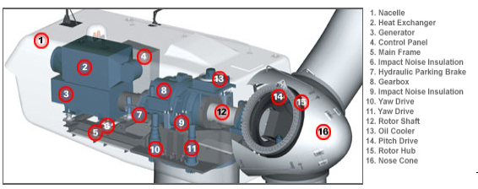

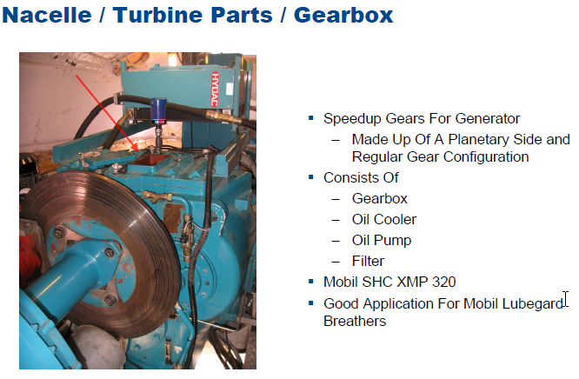
Inspection Covers

Typical Gearbox Opened Up
